This honor is bestowed upon
(Name)
For the Week of (Date Here)

Presented at (Name of Location)

Perfect Attendance

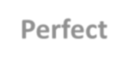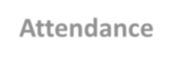

Signature (Sign Here)

