

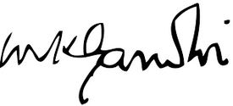

**Perfect**

**Attendance**

**Certificate**

**Presented To**

Mike Atherton de Senile Phillip

**Originally held on**

**Thursday, April 30, 2015**

**and is awarded up to 2 CCPDT & IAABS continuing education units**

|  |
| --- |
| **CERTIFICATE OF ATTENDANCE** |