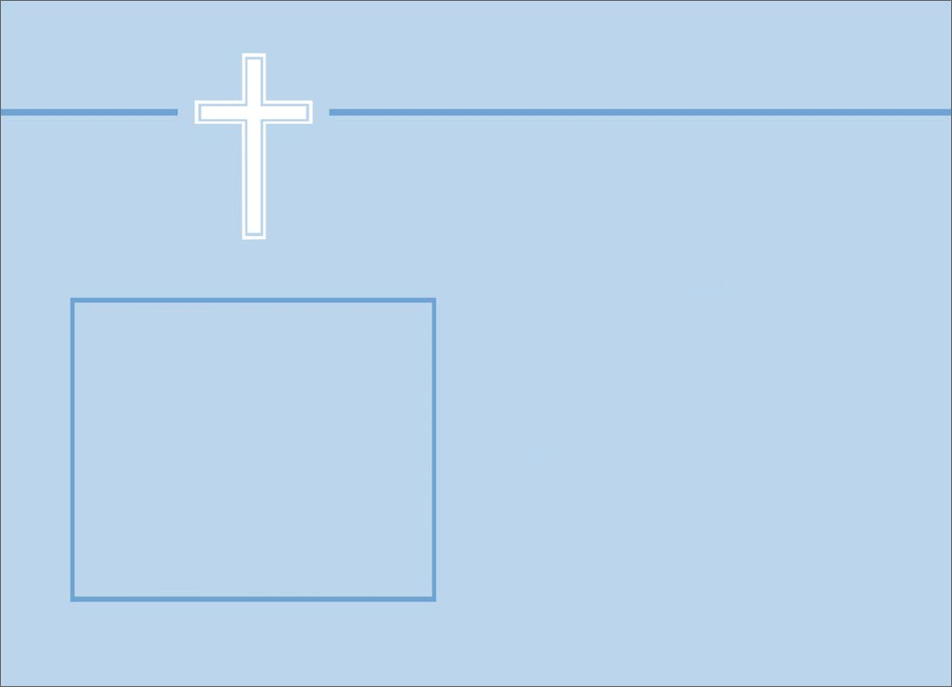

Let the little children come unto Me, for the kingdom of God belongs to such as these. --The Bible, Luke 18:16

**Certificate of Baptism**

________________________________

was baptized as a Christian in the name of the Father and the Son

and the Holy Spirit according to God’s Word.

at

Church Name

City, Province

_______________________________

Signature