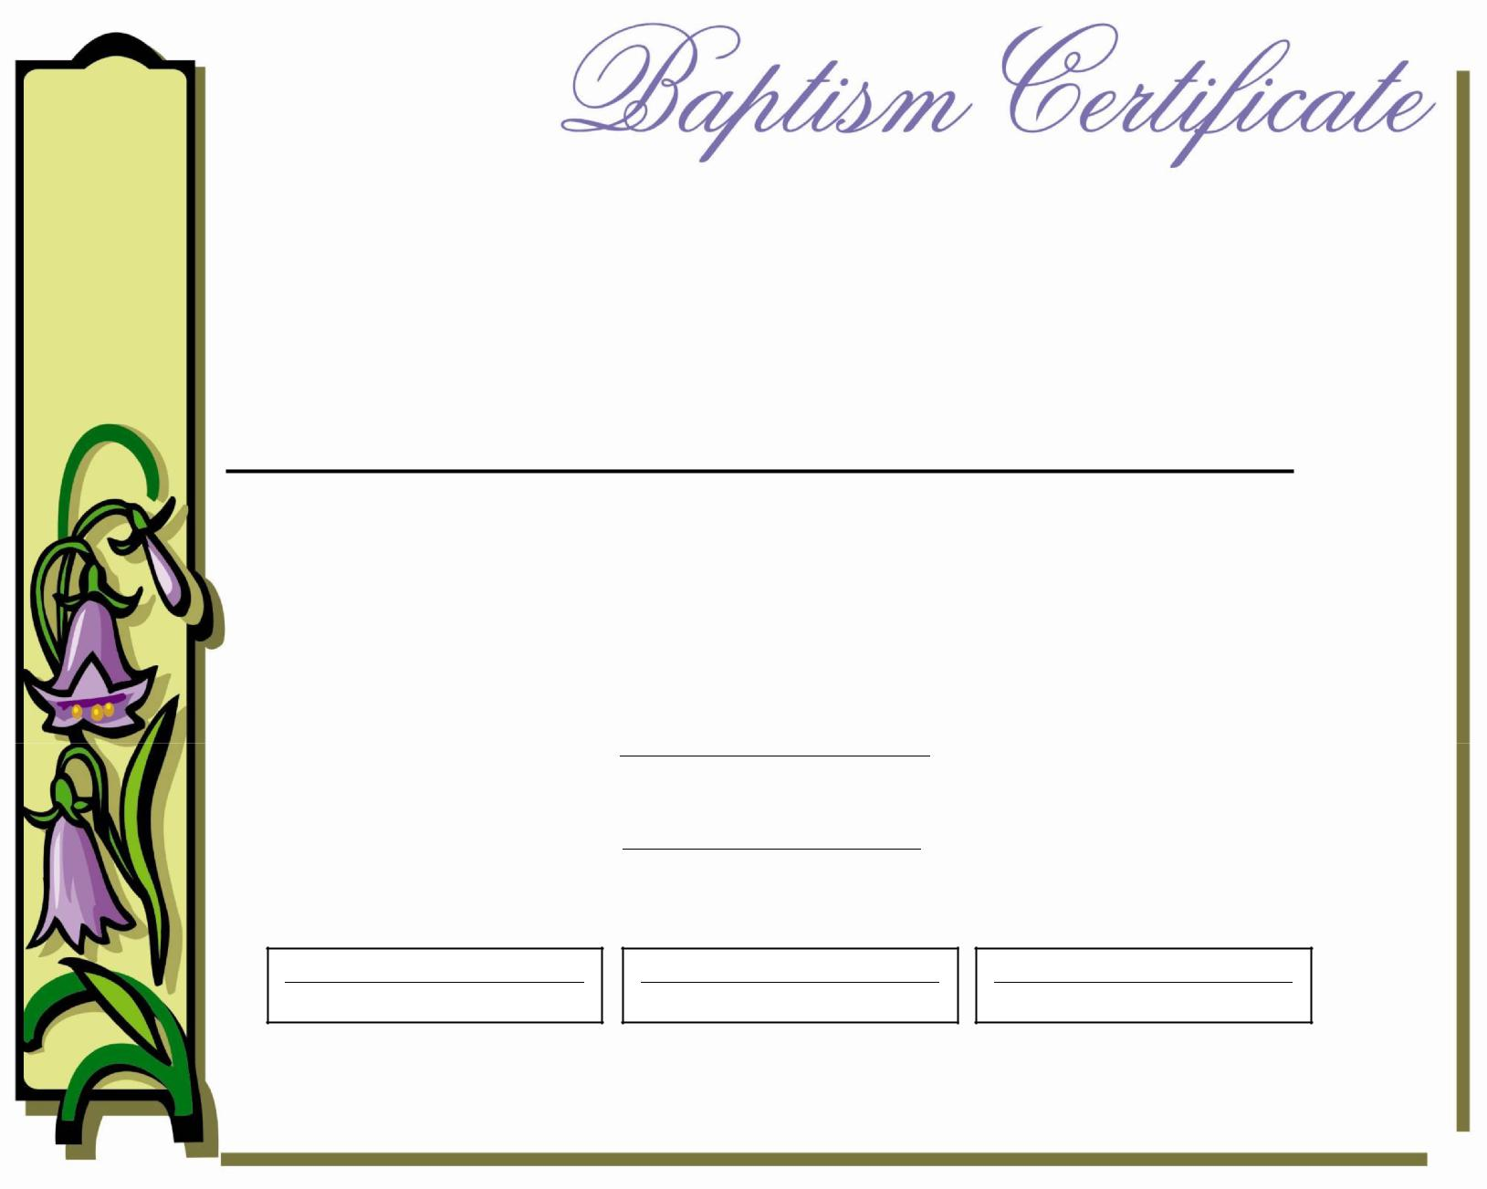

This Certifies That

(Name)

was

Baptized in the Name of the Father,

and of the Son, and of the Holy Spirit

on

(Date)

at
(Location)

(Minister/Officiant) (Sponsor/Godparent) (Sponsor/Godparent)

