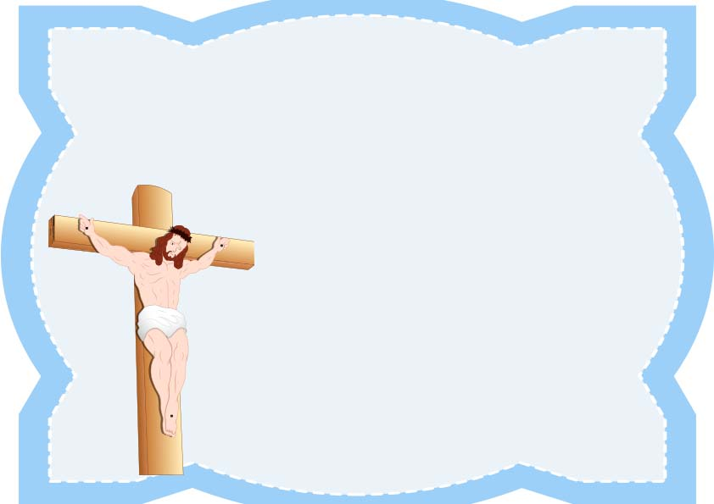

Jesus is the way , the truth, the life

FATHER :

THIS CERTIFIES THAT

_________________________

HAS RECEIVED A HOLY BAPTISM

ON _____ THIS DAY _____ OF THAT ____ IN THE YAER OF LORD

AT ________________________

BY _________________________

CERTIFICATE OF BAPTISM