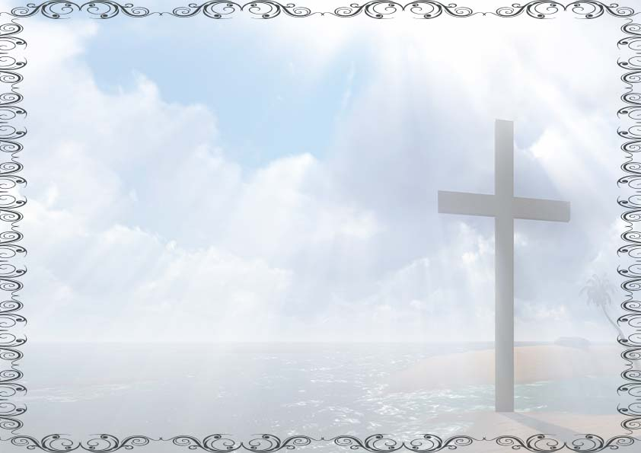

We do certify

According to the right of our Lord Jesus Christ,

We did administle to

____________________________

Born on __________________

Was baptized in ______________________

In the Holy water

NAME OF THE CHURCH :

PASTOR:

BAPTISm CERTIFICATE