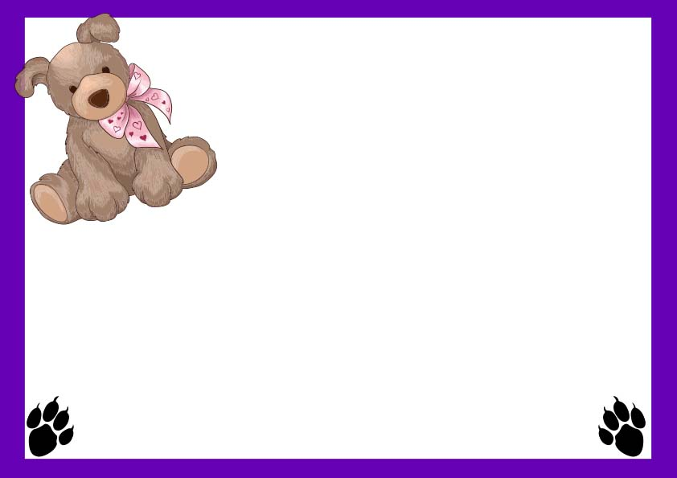

**Certificate of Adoption**

**__________________**

**Signature**

**________________**

**Date**

**This certifies that __________________**

**Has officially adopted ____________**

**By signing this certificate I promise to give my puppy a lifetime of love, care, attention and fun!**

**I promise to be their best friend forever..!**