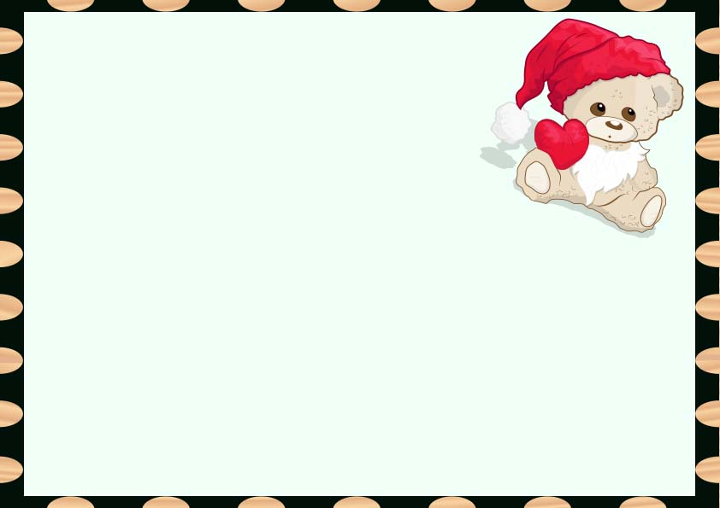

**This is to certify that**

**______________**

**Has officially adopted**

**______________**

**On**

**____________**

**Stuffed Animal Adoption Certificate**