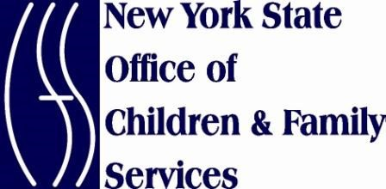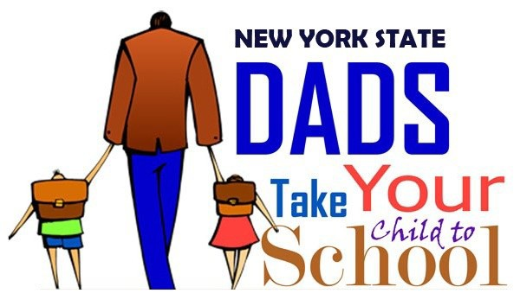

TUESDAY, SEPTEMBER 16, 2014

Certificate of Participation
This certificate is awarded to

In recognition of your participation in the
Dads Take Your Child to School Initiative

 | Joyce A. Thomas, Regional Administrator, |  | Sheila J. Poole, Acting Commissioner, | Kristin M. Proud, Commissioner,
 | U.S. Department of Health & Human Services |  | New York State Office of Children & Family Services | New York State Office of Temporary & Disability Assistance
 | Administration for Children and Families, Region II

