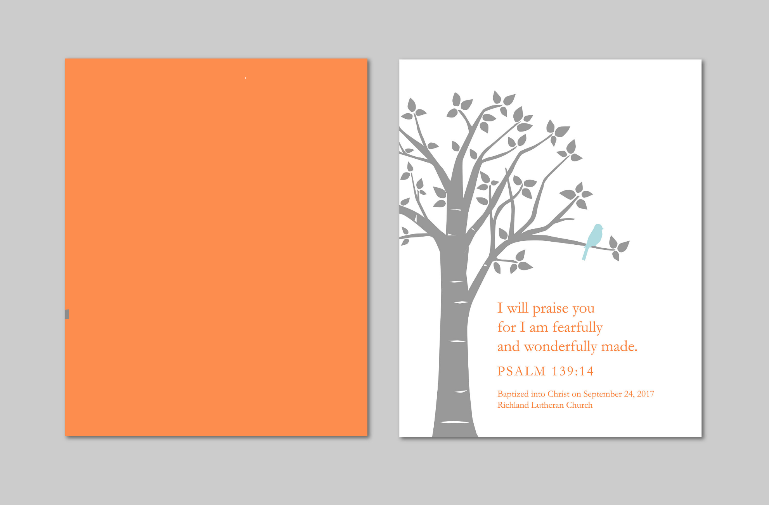

***Baby Dedication***

*This is to certify that*

*_______________________________________________________*

*was Presented to the Lord at ______________ Church*

*On the _______ Day of __________ In the Year ___________*

*At: _________ DOB: __________Place of Birth:______________________*

*Signed,*

*____________________________*

*Mother*

____________________________

Father

____________________________

Pastor