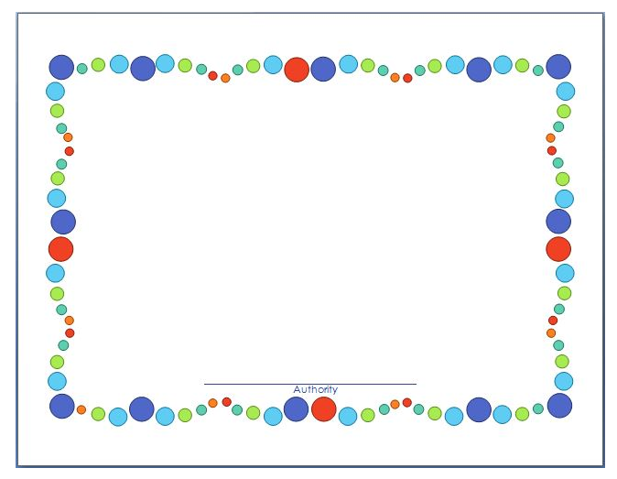

**Certificate of Recognition**

Presented to

(NAME)

In recognition for an Outstanding Vision,

Dedication &

Commitment to Excellence