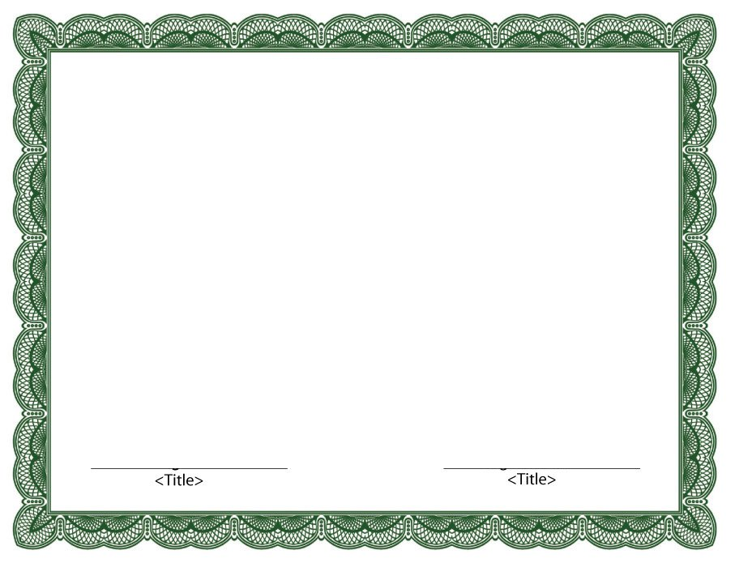

Presented to

__________________

In recognition and appreciation

for your continued support

and active involvement

Omaha County

Parks & Recreation Dept. 2014