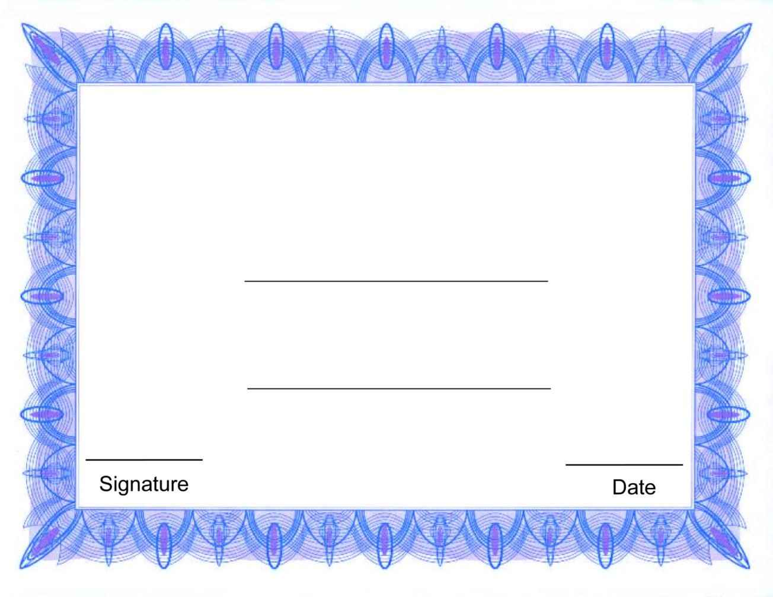

Certificate of Recognition

To

Name

Reson