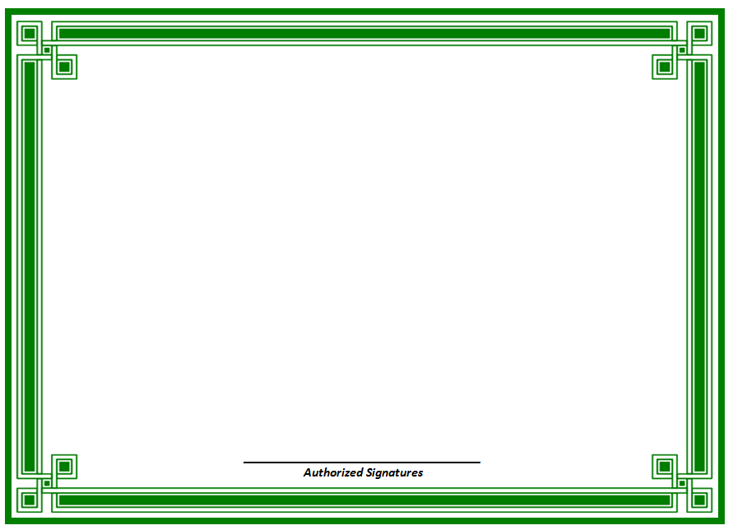

Certificate of Recognition for being

MOST VALUABLE PLAYER

____________________________

Quarterback

Congratulations

for a job well done!

December 2014