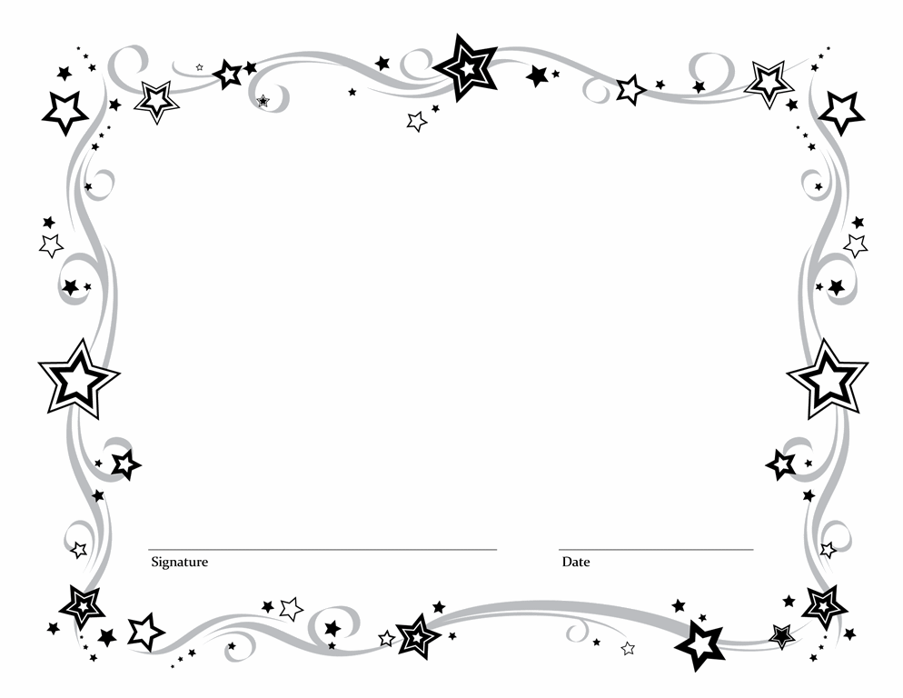

Presented to

_____________________________

Certificate of Recognition for your

generous contribution and assistance in the

construction of the David P. Smithton

Community Center

January 2014