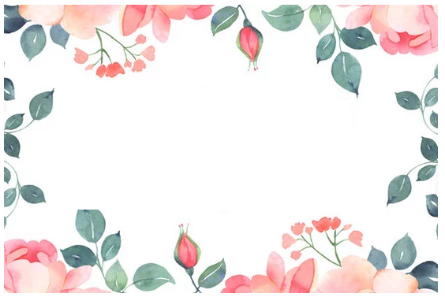

Presented to

________________________________________

In grateful recognition

of your untiring efforts

in organizing the

Annual Gala Ball

2014