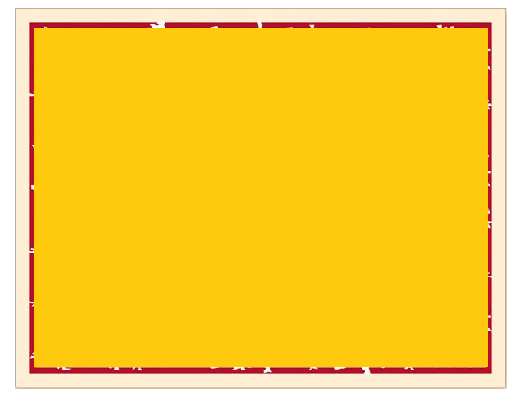

Presented to

_____________________________

This certificate of recognition is presented

to express our deep appreciation for the outstanding leadership you have afforded the

company

in our efforts to support the LEON COUNTY

UNITED WAY CAMPAIGN

___________(year)