|  |  |  |  |  |  |  |  |  |  |  |  |  |  |  |  |  |  |  |  |  |  |  |  |  |  |  |  |  |  |  |  |
| --- | --- | --- | --- | --- | --- | --- | --- | --- | --- | --- | --- | --- | --- | --- | --- | --- | --- | --- | --- | --- | --- | --- | --- | --- | --- | --- | --- | --- | --- | --- | --- |
|  | **STATE OF HAWAII** | | |  |  |  |  |  |  |  |  |  |  |  |  |  |  |  |  |  |  |  |  |  |  | HAWAII MMA PROGRAM | | | | |  |
|  |  |  |  |  |  | **MUST BE COMPLETED AND** | | | | | | | | | | |  |  |  |  |  |  |  | P.O. BOX 3469 | | | |  |
|  | HAWAII MMA PROGRAM | | |  |  |  |  |  |  |  |  |  |  |  |  | HONOLULU, HI 96801 | | | |  |
|  |  |  |  |  |  | **SIGNED BY M.D. OR D.O.** | | | | | | | | | | |  |  |  |  |  |  |  |  |
|  | **CONTESTANT'S PHYSICAL EXAMINATION** | | | | | |  |  |  |  |  |  |  | PHONE NO. (808) 586-2701 | | | | | |  |
|  |  |  |  |  |  |  |  |  |  |  |  |  |  |  |  |  |  |  |  |  | FAX (808) 586-2874 | | | |  |
|  |  |  |  |  |  |  |  |  |  |  |  |  |  |  |  |  |  |  |  |  |  |  |  |  |  |  |  |
|  |  | |  |  |  |  |  |  |  |  |  |  |  |  |  |  |  |  |  |  |  |  |  |  |  |  | |  |  |  |  |
|  | NAME (LAST, First, Middle) | | |  |  |  |  |  |  |  |  |  |  |  |  |  |  |  |  |  |  |  |  |  | DATE OF EXAM | | |  |  |  |  |
|  |  | |  |  |  |  |  |  |  |  |  |  |  |  |  |  |  |  |  |  |  |  |  |  |  |  |  |  |  |  |  |
|  | RING NAME | | |  |  |  |  |  |  |  |  |  |  |  |  |  |  |  |  | SOCIAL SECURITY NO. | | | | | | |  |  |  |  |  |
|  |  | |  | |  |  | |  |  |  |  |  |  |  |  |  | |  |  |  |  |  |  |  |  |  | |  |  |  |  |
|  | CURRENT ADDRESS (Include Apt. No., City, State & Zip Code) | | | | | | |  |  |  |  |  | TELEPHONE NO. | | | | | | |  |  |  |  |  | DATE OF BIRTH | | |  |  |  |  |
|  |  |  |  |  |  |  |  |  |  |  |  |  |  |  |  |  |  |  |  |  |  |  |  |  |  |  |  |  |  |  |  |
|  |  |  |  |  |  |  |  |  |  |  |  |  | AGE | | | |  |  |  |  |  |  |  |  | SEX: | | Male |  |  |  |  |
|  |  |  |  |  |  |  |  |  |  |  |  |  |  |  |  |  |  |  |  |  |  |  |  |  |  |  | Female |  |  |  |  |
|  |  | |  | |  |  | | |  |  |  |  |  |  |  |  |  |  |  |  |  |  |  |  |  |  |  |  |  |  |  |
|  | **MEDICAL HISTORY (PLEASE COMPLETE AS THOROUGHLY AS POSSIBLE)** | | | | | | | | | | | | | | | |  |  |  |  |  |  |  |  |  |  |  |  |  |  |  |
|  |  | |  | |  |  | | |  |  |  |  | |  |  |  | | | | |  |  |  | | |  |  |  |  |  |  |
|  | HAS APPLICANT EVER HAD ANY OF THE FOLLOWING CONDITIONS? PLACE AN "X" IF IT APPLIES TO YOU. | | | | | | | | | | | | | | | | | | | | | | | | | |  |  |  |  |  |
|  |  | Fainting Spells | | Rupture (hernia) | | | |  |  | Chest Pain | | | | | | |  |  |  |  |  |  | Operations | | | |  |  |  |  |  |
|  |  | Shortness of Breath | | Swollen Joints | | | |  |  | Rheumatism | | | | | | |  |  |  |  |  |  | Diabetes | | | |  |  |  |  |  |
|  |  | Frequent Headaches | | Convulsions (fits) | | | |  |  | Chronic Cough | | | | | | |  |  |  |  |  |  | Bleeding Disorder | | | | |  |  |  |  |
|  |  | Spitting of Blood | | Cerebral Hemorrhage or any other serious head injury | | | | | | | | | | | | |  |  |  |  |  |  |  |  |  |  |  |  |  |  |  |
|  | |  |  | |  |  |  |  |  |  |  |  |  |  |  |  |  |  |  |  |  |  |  |  |  |  |  |  |  |  |  |
| 1. | | HAVE YOU EVER BEEN HOSPITALIZED? . . . . . . . . . . | | | | | . . . . . . . . | . | . . . . . . . . . . . . . | . . . . . | . . . . | . . . . | . . . . |  | . . | . . . . | . . . . |  | . | . . . | . . . . | . | . . . . . . |  | . . . . . |  | Yes | No | | |  |
|  |  | If "Yes", give nature of problem(s), date(s), location(s) and attending physicians: | | | | | | | | | | | | | | |  |  |  |  |  |  |  |  |  |  |  |  |  |  |  |
|  | |  |  | |  |  |  |  |  |  |  |  |  |  |  |  |  |  |  |  |  |  |  |  |  |  |  |  |  |  |  |
|  | |  |  | |  |  |  |  |  |  |  |  |  |  |  |  |  |  |  |  |  |  |  |  |  |  |  |  |  | |  |
|  |  |  |  |  |  |  |  |  |  |  |  |  |  |  |  |  |  |  |  |  |  |  |  |  |  |  |  |  |  |  |  |
| 2. | | HAVE YOU EVER HAD EYE SURGERY? . . . . . . . . . . . . | | | | | . . . . . . . . | . | . . . . . . . . . . . . . | . . . . . | . . . . | . . . . | . . . | . | . . | . . . . | . . . . |  | . | . . . | . . . . | . | . . . . . | . | . . . . . |  | Yes | No | | |  |
|  |  | If "Yes", explain: | |  |  |  |  |  |  |  |  |  |  |  |  |  |  |  |  |  |  |  |  |  |  |  |  |  |  |  |  |
|  | |  |  | |  |  |  |  |  |  |  |  |  |  |  |  |  |  |  |  |  |  |  |  |  |  |  |  |  | |  |
|  |  |  |  |  |  |  |  |  |  |  |  |  |  |  |  |  |  |  |  |  |  |  |  |  |  |  |  |  |  |  |  |
| 3. | | HAVE YOU EVER HAD A RETINAL DETACHMENT? | | | | | . . . . . . . . | . | . . . . . . . . . . . . . | . . . . . | . . . . | . . . . | . . . . |  | . . . | . . . | . . . . | . |  | . . . . | . . . | . | . . . . . . |  | . . . . . |  | Yes | No | | |  |
|  |  | If "Yes", explain: | |  |  |  |  |  |  |  |  |  |  |  |  |  |  |  |  |  |  |  |  |  |  |  |  |  |  |  |  |
|  | |  | | |  |  | | |  |  |  | | |  |  |  |  |  |  |  |  |  |  |  |  |  |  |  |  | |  |
|  |  |  |  |  |  |  |  |  |  |  |  |  |  |  |  |  |  |  |  |  |  |  |  |  |  |  |  |  |  |  |  |
| 4. | | DO YOU REGULARLY OR OCCASIONALLY TAKE ANY MEDICATIONS? . . . . . . . . . . . . . . . . . . . . . . . . . . | | | | | | | | | | | | | | | . . . . . |  |  | . . . . | . . . | . | . . . . . . |  | . . . . . |  | Yes | No | | |  |
|  |  | If "Yes", give name(s), frequency and dose: | | | | |  |  |  |  |  |  |  |  |  |  |  |  |  |  |  |  |  |  |  |  |  |  |  |  |  |
|  | |  | | |  |  | | |  |  |  | | |  |  |  |  |  |  |  |  |  |  |  |  |  |  |  |  | |  |
|  |  |  |  |  |  |  |  |  |  |  |  |  |  |  |  |  |  |  |  |  |  |  |  |  |  |  |  |  |  |  |  |
| 5. | | HAVE YOU PREVIOUSLY BEEN INJURED IN A BOXING/KICKBOXING/MARTIAL ARTS EVENT? . . . . . | | | | | | | | | | | | | | | . . . . |  | . | . . . | . . . . | . | . . . . . |  | . . . . . . |  | Yes | No | | |  |
|  |  | If "Yes", describe injuries: | |  |  |  |  |  |  |  |  |  |  |  |  |  |  |  |  |  |  |  |  |  |  |  |  |  |  |  |  |
|  | |  | | |  | |  |  |  |  |  |  |  |  |  |  |  |  |  |  |  |  |  |  |  |  |  |  |  |  |  |
|  |  |  |  |  |  |  |  |  |  |  |  |  |  |  |  |  |  |  |  |  |  |  |  |  |  |  |  |  |  |  |  |
| 6. | | LONGEST DURATION OF UNCONSCIOUSNESS: | | | | |  |  |  |  |  |  |  |  |  |  |  |  |  |  |  |  |  |  |  |  |  |  |  |  |  |
|  | |  | |  |  | |  |  |  |  |  | | |  |  |  |  | | | |  |  |  | | |  |  |  |  |  |  |
|  |  |  |  |  |  |  |  |  |  |  |  |  |  |  |  |  |  |  |  |  |  |  |  |  |  |  |  |  |  |  |  |
| 7. | | WHAT IS YOUR RECORD? | | Wins: | | |  |  | Losses: | | | | | | | | Draws: | | | | | | | | | |  |  |  |  |  |
|  | |  | | |  | |  |  |  |  |  |  | |  |  |  |  |  |  |  |  |  |  |  |  |  |  |  |  |  |  |
|  |  |  |  |  |  |  |  |  |  |  |  |  |  |  |  |  |  |  |  |  |  |  |  |  |  |  |  |  |  |  |  |
| 8. | | WHAT IS YOUR RECORD FOR THE LAST YEAR? | | | | | Wins: |  |  |  |  | Losses: | | | | |  |  |  |  |  |  |  |  | Draws: | |  |  |  |  |  |
|  |  |  |  |  |  |  |  | |  | |  | | |  | |  |  |  |  |  |  |  |  |  |  |  |  |  |  |  |  |
|  |  |  |  |  |  |  | Number of times lost by TKO or KO? | | | | | | | | | |  |  |  |  |  |  |  |  |  |  |  |  |  |  |  |
|  | |  | | | | | | | | | | | |  | | |  |  |  |  | |  | | | | |  |  |  |  |  |
|  |  |  |  |  |  |  |  |  |  |  |  |  |  |  |  |  |  |  |  |  |  |  |  |  |  |  |  |  |  |  |  |
| 9. | | WHEN WERE YOU LAST GIVEN A MEDICAL SUSPENSION FROM A COMMISSION/PROGRAM? | | | | | | | | | | | | | | |  |  |  | Date: | | | | | | |  |  |  |  |  |
|  |  |  |  |  |  |  |  |  |  |  |  |  |  |  |  |  |  |  |  |  |  |  |  |  |  |  |  |  |  |  |  |

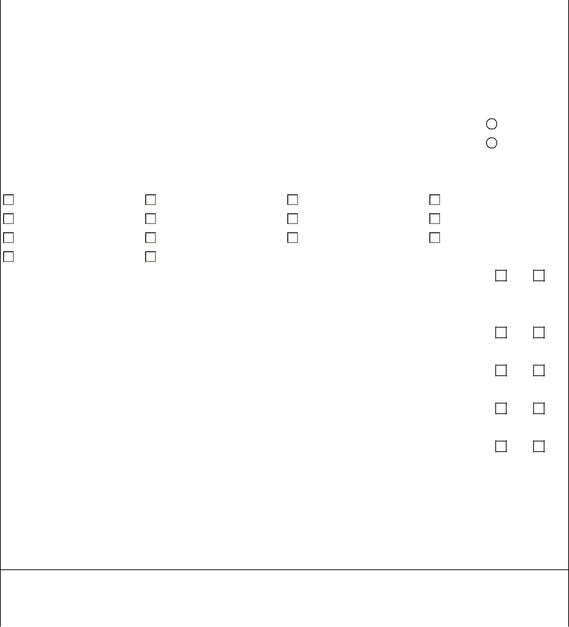

1. WHY WERE YOU SUSPENDED?
2. (FEMALE CONTESTANTS ONLY) DATE OF LAST MENSTRUAL PERIOD?

**\*\* SIGNATURES REQUIRED ON PAGE 3 \*\***

(CONTINUED ON PAGE 2)

MMA-03 0813R

Print Name of Applicant: Date:

**PHYSICAL EXAM**

|  |  |  |
| --- | --- | --- |
| HEIGHT | WEIGHT | TEMPERATURE |
|  |  |  |

|  |  |  |  |  |  |  |  |  |  |  |  |  |  |  |  |  |  |  |  |
| --- | --- | --- | --- | --- | --- | --- | --- | --- | --- | --- | --- | --- | --- | --- | --- | --- | --- | --- | --- |
| **OTOLOGIC** |  |  |  |  |  |  | **FACE** | | | |  |  |  |  |  |  |  |  |  |
| External Trauma |  |  |  | Yes | No |  | Recent Trauma | | | |  |  |  | Yes | | No |  |  |  |
| Perforated Drum |  |  |  | Yes | No |  | Jaw and Temporomandibular Joints | | | | | | | Normal | | Abnormal | | |  |
|  |  |  |  |  |  |  |  |  |  |  |  |  |  |  |  |  |  |  |  |
| **OROPHARYNX** |  |  |  |  |  |  | **ADENOPATHY** | | | |  |  |  | Yes | | No |  |  |  |
|  |  |  |  |  |  |  |  |  |  |  |  |  |  |  |  |  |  |  |
|  |  |  |  |  |  |  |  |  |  |  |  |  |  |  |  |  | |  |  |
| Loose Teeth |  |  |  | Yes | No |  | **LUNGS (RALES)** | | | |  |  |  | Normal | | Abnormal | | |  |
|  |  |  |  |  |  |  |  |  |  |  |  |  |  |  |  |  | |  |  |
| **NOSE** |  |  |  |  |  |  | **TESTES** | | | |  |  |  | Normal | | Abnormal | | |  |
|  |  |  |  |  |  |  |  |  |  |  |  |  |  |  |  |  |  |  |
|  |  |  |  |  |  |  |  |  |  |  |  |  |  |  |  |  |  |  |  |
| Instability |  |  |  | Yes | No |  | **ENLARGED GLANDS** | | | |  |  |  | Yes | | No |  |  |  |
|  |  |  |  |  |  |  |  |  |  |  |  |  |  |  |  |  |  |  |  |
| Recent Trauma |  |  |  | Yes | No |  | **GOITER** | | | |  |  |  | Yes | | No |  |  |  |
| Obstruction |  |  |  | Yes | No |  |  |  |  |  |  |  |  |  |  |  |  |  |  |
|  |  |  |  | **CARDIOVASCULAR** | | | |  |  |  |  |  |  |  |  |  |
|  |  |  |  |  |  |  |  |  |  |  |  |  |  |  |  |
|  |  |  |  |  |  |  | Blood Pressure (supine) | | | |  |  |  | (upright) | |  |  |  |  |
| **ABDOMEN** |  |  |  |  |  |  |  |  |  |  |  |  |  |
|  |  |  |  |  |  |  |  |  |  |  |  |  |  |  |  |  |  |  |
| Enlargement of Liver |  |  |  | Yes | No |  | Blood Pressure after 100 hops | | | | | | |  |  |  |  |  |  |
|  |  |  |  |  |  |  |  |  |  | | |  |  |  |  |  |  |  |  |
| Hernia |  |  |  | Yes | No |  | Blood Pressure 2 minutes later | | | | | | |  |  |  |  |  |  |
| Enlargement of Spleen | | | | Yes | No |  | Heart Rate (supine) | |  | |  |  |  |  |  |  |  |  |  |
|  |  |  |  |  |  |  |  |  |  |
| Femoral | Inguinal | | | Ventral | |  | Heart Rate (after 2 minutes of exercise) | | | | | | |  |  |  |  |  |  |
|  |  |  |  |  |  |  |  |  |  |  |  |  |  |  |  |  |  |  |  |
|  |  |  |  |  |  |  |  |  |  |  |  |  |  |  |  |  |  |  |  |
| **HEART** |  |  |  |  |  |  |  |  |  |  |  |  |  |  |  |  |  |  |  |
| Pulse Rhythm |  | Normal | | | Abnormal | | | | | | Apical Impulse | | |  | Heavy | | Normal | |  |
| Enlargement |  | Yes | |  | No |  |  |  |  |  | Murmurs | | |  | Yes |  | No | |  |
|  | |  |  |  |  |  |  |  |  |  |  |  |  |  |  |  |  |  |  |
| **BREAST (FEMALE CONTESTANTS)** | | | |  |  |  |  |  |  |  |  |  |  |  |  |  |  |  |  |
| Mass |  | Yes | |  | No |  |  |  |  |  | Tenderness | | |  | Yes |  | No | |  |
|  | |  |  | | | | |  | | |  |  |  |  |  |  |  |  |  |
| **GYNECOLOGICAL EXAMINATION (FEMALE CONTESTANTS)** | | | | | | | | | | |  |  |  |  |  |  |  |  |  |
| Normal |  |  |  | Abnormal | |  |  |  |  |  |  |  |  |  |  |  |  |  |  |
|  | |  |  |  |  |  |  |  |  |  |  |  |  |  |  |  |  |  |  |
| **MUSCULOSKELETAL** | | | |  |  |  |  |  |  |  |  |  |  |  |  |  |  |  |  |
| Hands | Normal | | |  | Abnormal |  | Comments: | | | |  |  |  |  |  |  |  |  |  |
|  |  |  |  |  |  |  |  |  | | |  |  |  |  |  |  |  |  |  |
| Wrists | Normal | | |  | Abnormal |  | Comments: | | | |  |  |  |  |  |  |  |  |  |
|  |  |  |  |  |  |  |  |  | | |  |  |  |  |  |  |  |  |  |
| Elbows | Normal | | |  | Abnormal |  | Comments: | | | |  |  |  |  |  |  |  |  |  |
|  |  |  |  |  |  |  |  |  | | |  |  |  |  |  |  |  |  |  |
| Shoulder Girdle | Normal | | |  | Abnormal |  | Comments: | | | |  |  |  |  |  |  |  |  |  |
|  |  |  |  |  |  |  |  |  | | |  |  |  |  |  |  |  |  |  |
| Lower Extremities | Normal | | |  | Abnormal |  | Comments: | | | |  |  |  |  |  |  |  |  |  |
|  |  |  |  |  |  |  |  |  |  |  |  |  |  |  |  |  |  |  |  |
|  |  |  |  |  |  |  |  |  |  |  |  |  |  |  |  |  |  |  |  |
| **NEUROLOGIC** |  |  |  |  |  |  |  |  |  |  |  |  |  |  |  |  |  |  |  |
| Mental Status | Orientation | | |  |  |  |  |  |  |  | /3 |  |  |  |  |  |  |  |  |
|  |  |  |  |  |  |  |  |  |  |  |  |  |  |  |  |  |  |  |  |
|  | 5-minute recall | | |  |  |  |  |  |  |  | /3 |  |  |  |  |  |  |  |  |
|  |  | |  |  |  |  |  | | | |  |  | |  | |  |  |  |  |
| Cranial Nerves | Normal | | |  | Abnormal |  | Strength | | | |  | Normal | | Abnormal | |  |  |  |  |
| Tone | Normal | | |  | Abnormal |  | Gait | | | |  | Normal | | Abnormal | |  |  |  |  |
| Coordination: | Normal | | |  | Abnormal |  | Tandem Gait | | | |  | Normal | | Abnormal | |  |  |  |  |
| Finger to Nose |  |  |  |  |  |  |  |

(CONTINUED ON PAGE 3) -2-

Print Name of Applicant: Date:

**COMMENTS OF EXAMINING PHYSICIAN**

|  |  |  |
| --- | --- | --- |
| I hereby certify that I have examined the named individual and in my opinion, this **individual** | **is or** | **is not** medically fit to |

participate as a contestant in a professional boxing, kick boxing, martial arts contest or wrestling. I also attest that I do not have a professional

relationship with, nor financial interest in the earnings of, this individual.

**MUST BE COMPLETED AND SIGNED BY M.D. OR D.O.**

|  |  |  |
| --- | --- | --- |
| PRINT NAME OF EXAMING PHYSICIAN | PHYSICIAN'S LICENSE NO. | PHYSICIAN'S PHONE NO. |
|  |  |  |
|  | ADDRESS OF PHYSICIAN |  |

SIGNATURE OF EXAMINIG PHYSICIAN

**MEDICAL RELEASE OF INFORMATION**

I hereby authorize the Hawaii MMA Program to release, disclose, and furnish to any other boxing or athletic commission affiliated with the Association of Boxing Commissions (ABC), any and all of my medical records concerning my licensure as a participant including, but not limited to, all required medical examinations, laboratory test results for the HIV, hepatitis virus and drug screening, hospital records, and any other information regarding conditions related to the propriety of my licensure as a participant (including history, findings, diagnosis, or prognosis).

I understand, and it is agreed, that the signing of this Medical Information Release is optional, and that my declining to sign this document will not result in any adverse action being taken against me by the Hawaii MMA Program based on my decision. I understand, and it is agreed, that the medical records described herein will not be released for any purpose other than for a member commission affiliated with the ABC to determine my eligibility to participate in a professional boxing, kick boxing, or martial arts events. I understand, and it is agreed, that this authorization shall remain in effect until June 30, of each odd numbered year and is relevant to all medical records described herein, whether such records were created prior to, or subsequent to, the date the authorization is signed.

By signing below, I hereby authorize the release of my medical information.

|  |  |
| --- | --- |
| SIGNATURE OF CONTESTANT | DATE |
|  |  |
| PRINT NAME |  |

This material can be made available for individuals with special needs. Please call the Licensing Branch Manager at (808) 586-3000 to submit your request.

-3-