COMPLETE PHYSICAL EXAMINATION FORM

INSTRUCTIONS: Only this form created by the Athletics Commission of Saskatchewan will be accepted in order to satisfy the requirement. This completed form can be emailed to acs@gov.sk.ca, faxed to 306-787-5523, or mailed to the Athletics Commission of Saskatchewan, 1st Floor—3211 Albert St, Regina, Saskatchewan, S4S 5W6.

APPLICANT INFORMATION (to be completed by the applicant)
Full name of applicant (first, middle, last): | Date of birth (month, day, year):

Address (street address, city, province/state, postal code/zip code, country):

Primary telephone no. (include area code): |  |  | Business telephone no. (include area code):
Sex (male or female): |  | Height: |  |  | Weight:
Amateur Boxing Record | Amateur Mixed Martial Arts Record |  |  | Other Amateur Combative Sport Record
Wins_____Losses_____Draw_____ Wins_____Losses_____Draw_____ |  |  |  | Wins_____Losses_____Draw_____
Pro Boxing Record | Pro Mixed Martial Arts Record |  |  | Other Pro Combative Sport Record
Wins_____Losses_____Draw_____ | Wins_____Losses_____Draw_____ |  |  | Wins_____Losses_____Draw_____
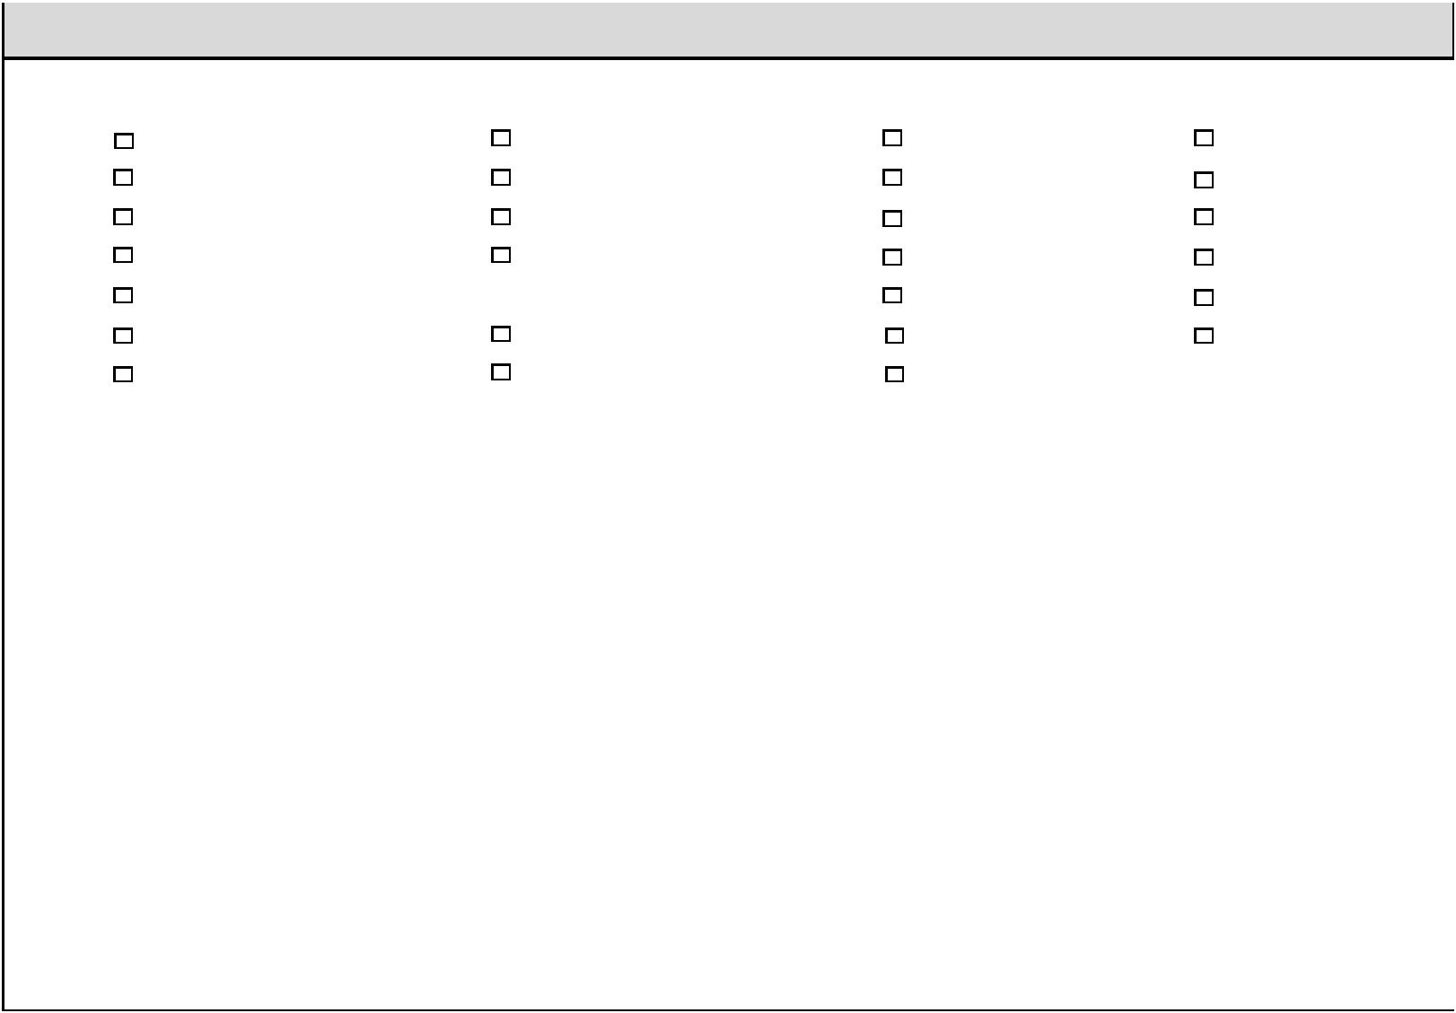

MEDICAL HISTORY (to be completed by the applicant)

Have you ever had any of the following conditions?

Fainting spells | Rupture (hernia) | Chest pains | Operations
Shortness of breath | Swollen joints | Rheumatism | Diabetes
Frequent headaches | Convulsions (fits) | Chronic cough | Asthma
Bleeding disorders | Palpitations (racing heart rate) | Seizures | Allergies
Cerebral hemorrhage or any other serious head injury |  | Spitting of blood | Concussion
Hearing problems | Facial injuries | Thyroid disorders | Ulcers
Kidney disease | Pinched nerve | Broken bone

If “Yes” to any of the above, explain: ____________________________________________________________________________

__________________________________________________________________________________________________________

Have you seen a doctor for any medical problem in the last 3 months? If yes, explain: _____________________________________

__________________________________________________________________________________________________________

Do any diseases run in your family? _____________________________________________________________________________

__________________________________________________________________________________________________________

Number of knockouts received:___________________ Date of last knockout (month, day, year): ______________________

Longest duration of unconsciousness: ______________________________________________________________________ _____

Length of time before resuming combative sports after last knockout: _________________________________________________

Have you ever been knocked unconscious in other sport or in any other way? If yes explain:_______________________________

__________________________________________________________________________________________________________

1

PHYSICAL EXAMINATION (to be completed by the examining medical practitioner)

Pulse at rest: ____________ |  |  |  |  |  |  |  |  |  |  | Pulse after 100 hops: ____________
Blood pressure at rest: ____________ |  |  |  |  |  |  |  |  |  |  | Blood pressure after 100 hops: ____________
GLANDS
Enlarged (yes/no): ____________ |  |  |  |  |  |  |  |  |  |  | Goiter (yes/no): ____________
HEART
Pulse rhythm (regular/irregular): ____________ |  |  |  |  |  |  |  |  |  |  | Apical impulse (heavy/normal): ____________
Enlargement (yes/no): ____________ |  |  |  |  |  |  |  |  |  |  | Murmurs (yes/no): ____________
LUNGS
Rales (yes/no): ____________
BREASTS
Mass (yes/no): ____________ |  |  |  |  |  |  |  |  |  | Tenderness (yes/no): ____________ |  | Discharge (yes/no): ____________
ABDOMEN
Enlargement of liver (yes/no): ____________ |  |  |  |  |  |  |  |  |  |  | Enlargement of spleen (yes/no): ____________
Hernia (yes/no): ____________ |  |  |  |  |  |  |  |  |  | If yes, femoral, inguinal or ventral: ____________
TESTICLES
Normal (yes/no): ____________
REFLEXES
Pupils: ____________ |  |  |  |  |  |  |  |  | Knee jerks: ____________ |  | Romberg: ____________ |  | Babinski: ____________
SKIN
Rash: ____________ |  |  |  |  |  |  |  |  | Boils: ____________ |  | Any other unhealed wounds: ____________

Medications:

DIAGNOSTICS (The original lab report with applicant’s name and date the tests were performed must be submitted)

- HIV

- Hepatitis B (ANTIGEN REPORT REQUIRED EVEN IF IMMUNIZED)

- Hepatitis C

- Women only: Pregnancy (LAB TEST WITHIN 7 DAYS PRIOR TO EVENT)

CERTIFICATION (to be completed by the examining medical practitioner)

I hereby certify that based on the statements made by the applicant on the reverse side of this form, my physical findings, and pending any medical testing not yet reviewed, it is my opinion that ___________________________________ IS or IS NOT in good physical condition and is medically cleared to be licensed as a competitor in a combative sport.

Reason not cleared for competition: _____________________________________________________________________

Name of medical practitioner (print): _________________________________ Signature:__________________________

Date of examination: _________________________________________________________________________________

Office address: __________________________________________ Telephone number: ___________________________

E-mail: _________________________________________________ Fax: _______________________________________

2

