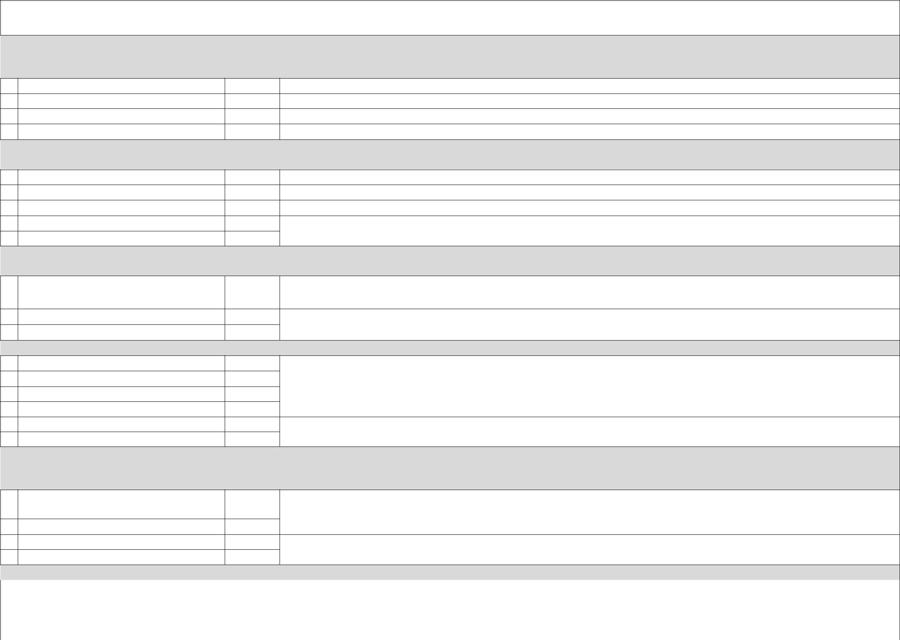
Acupuncture-­‐ initial 15”/ CPT unit Acupuncture-­‐ subsequent 15”/ CPT unit Acupuncture-­‐ initial 15”/CPT unit Acupuncture-­‐ subsequent 15”/CPT unit

Acupuncture-­‐ 2nd CPT unit
Manual therapy-­‐ 1st CPT unit
Manual therapy-­‐2nd CPT unit

Acupuncture-­‐ 1st CPT unit

Phone calls & consults -­‐??”
Phone calls & consults -­‐??”
Team conference-­‐??”
Team conference-­‐??”
Medical records administration fee
Medical records copying fee

Separate code-­‐ additional 30”
Separate code-­‐ additional 1hr

-­‐21

Modifier-­ prolonged/continuous

Re-­‐eval-­‐ 5”
Re-­‐eval-­‐ 10”
Re-­‐eval-­‐ 15”

Initial exam-­‐ 10”
Initial exam-­‐ 20”
Initial exam-­‐ 30”

Same for manual therapy, except that the CPT unit is in larger unit of time.

15-­‐23”
8-­‐22”
23-­‐30”

When an insurance companyrequests medical records it is allowable & expected to charge for the request. E.g. $24/hr for administration [only 1 unit]. 10cents per page for copies [multiple units].
CPT UNITS for PROCEDURES & MODALITIES-­ 24D
Procedures are therapies [e.g. acupuncture] while modalities are physical objects used on patient [e.g. e-­‐stim]. Modalities are supervised meaning you can leave the room. Or they are constantly monitored, meaning you stay with the patient. Both are billed in units of time.
8-­‐15” Acupuncture CPT unit is actually in increments of 8 minutes. After 8 minuets of treatment it is considered a full 15”. After 16 minutes it isconsidered a full 30” treatment and so on…USUALLY will only be
paid for 2 acupuncture codes.

99371
99373
99361
99362
S9981
S9982

MICELLANEOUS/MANAGEMENT SERVICE
Rarely reimbursed

99355
99354

Primarily used by & re-­‐reimbursed by workman’s comp and need excellent documentation

Most commonly used by acupuncturists
Most commonly used by acupuncturists
Never used. This is for acute care and emergency visitsand primary care providers
TIME MODIFIERS/CODES
Used if one needs to extend the time taken for initial exam or re-­‐eval
Modifier to Add to initial exam or Re-­‐eval code. It is rarely reimbursed. It isbetter to just go to a higher codee.g. from 99202 to 99203 or use a separate code below

99211
99212
99213
99214
99215

Most commonly used by acupuncturists
Add this modifier if you initial E&M and treat patient the same visit
RE-­EVALUATION 24D
Can bill upon every subsequent patient contact

INITIAL E&M 24D
Good for 3 years, after which time you can bill again for an initial E&M.
In other words, one can only bill this once in 3 years, even if the patient has not been treated regularly.
99201
99202
99203
-­‐59

Super-­Bill
Information from Acu-­‐Insurance.com http://acu-­‐insurance.com/

CPT CODES for PROCEDURES & MODALITIES 24D

 |  | 97810/ $15 | w/o | e-­‐stim
 |  | 97811/ $15 | w/o | e-­‐stim and reinsertion of needles. [Must use 97810 & 97811 together]
 |  | 97813/ $15 | w/ | e-­‐stim
 |  | 97814/ $15 | w/ | e-­‐stim and reinsertion of needles. [Must use 97813 & 97814 together]

E-­‐stim: start ing without e-­‐stim then continue billing as such. Start with e-­‐stim, continue billing as such. So if you are going to use e-­stim… use it first! In other words:

1. | If the fist 15” of your treatment did not involve e-­‐stim [97810] but the second 15” of treatment did, you bill as if you did notuse e-­‐stim at all.
 | You bill 97810 & 97811.
2. | If the first 15” of your treatment involved e-­‐stim [87813] but the second 15” of your treatment did not, you billas if you continuously used e-­‐stim.
 | You bill 97813 & 87814.
 | Warm needle | -­‐59 | Add this modifier to the above codes whenever there issimultaneous overlap with acupuncture & this modality
 | Manual: Cupping, tuina | 97140 | This is the code that coverstuina. It pays more than the code for massage
 | Manual: Bilateral or separate form | 97140-­‐50 | Add -­50 modifier to 1 or 2 CPT units for manual therapy that has a significant bilateral component.
 | acupuncture |  | Add -­50 modifier to manual therapy if insurer requires clear differentiation between manual therapy given separately
 |  |  | from acupuncture in order to be paid for both. Some insurers will not pay if differentiation is not made.
 | Massage | 97124 | Do not use this code for tuina etc. because it does not reflect the scope of treatment rendered.
 | Moxa $5 | 97026 | Just moxa
 | Hot/cold packs $5 | 97010
 | e-­‐stim | 97014 | Different than acupuncture w/ e-­‐stim. E.g. unattended TENS.
 | Heat lamp $10 | 97026 | Infrared
 | Physiotherapy | 97110 | ROM, exercises, gait training etc.
 | Kinesio-­‐taping
 | ROM | 97111
 | Unlisted procedures | 97139
 | Unlisted modalities | 97039
 | Urinalysis Manual | 81002 | Lab tests
 | Pregnancy test Urine | 81025
 | Blood Sugar test manual
 | Biometrics/physical performance | 97750 | This would be using a physical tool to quantifysprain, ADL, ROM etc. improvement or limitations.
 | tests, screens |  | [Outcome Assessment & Measurement Tools to document functional improvement, activities of daily living, pain etc.
 |  |  | Use them to document improvement, verify & justify thischarge!. Find some at http://acu-insurance.com/clinical-
 |  |  | aspects/outcome
 | Needles & supplies | A4215 | This is a HCPCS code used by the Medicare/Medicaid system, which reimburses for needles & supplies.
 |  |  | Other insurers may pay… not likely.
 | Smoking & Alcohol cessation | 99406 | 3-­‐ 10 minutes' duration are reimbursed by Medicare CPT [implemented in January 2008].See
 | counseling (5-­A’s); |  | https://online.epocrates.com/noFrame/showPage.do?method=diseases&MonographId=411&ActiveSectionId=41
 | 1] Ask about a smoking status. | 99407 | >10 minutes
 | 2) Advise to quit.
 | 3) Assess readiness to quit.
 | 4) Assist in quit attempts.
 | 5) Arrange follow-­‐up on attempts
 | (e.g. NADA).
 | ICD-­9-­ CM DIAGNOSIS CODES & QUALIFIERS
 |  | Office Ally
ACCIDENT |  | HEADACHES
Collision with motor vehicle. Passenger | E812.1 | TMJ | 848.1
Collision with Motor Vehicle. DRIVER | E812.0 | Headaches. tension | 307.81
NECK |  | headache | 784.0
Neck Pain. Cervicalgia | 723.1
Cervical spine sprain/strain | 847.0
BACK
Back Pain. Unspecified | 724.5
Back Pain. Lumbar | 724.2
Thoracic sprain/strain | 847.1
Lumbar sprain/strain | 847.2
Lumbosacral sprain/strain | 846.0
Sciatica | 724.3
Sacral strain/sprain | 847.3
Coccyx sprain /strain | 847.4
BLE
Lumbosacral /Thoracic neuritis / radiculopathy | 724.4
Pain. Knee | 719.46
Pain. Hip | 719.45
Pain. Foot | 719.47
BUE
Shoulder/upper arm strain/sprain | 840.9
Pain. Wrist | 719.43
Pain. Shoulder | 719.41
Forearm Injury. Unspecified | 913.8
Wrist Injury | 959.3
Brachial neuritis/ radiculitis | 723.4
Carpal tunnel | 354
GENERAL BODY PAIN
Osteoarthritis | 715.9
fibroyalgia / myositis, unspecified | 729.1

