Pain Clinic Patient Progress Note

Date last seen:
How would you best describe your pain? (please check all that apply)
Dull, throbbing, aching Shock-like, numb or tingling Burning Other
Please rate your pain by circling the one number that best describes your pain on the average over the past few days (While taking your pain medication)
1 2 3 4 5 6 7 8 9 10
What makes your pain worse?
standing walking sitting bending or twisting ice heat
What makes your pain better?
` standing walking sitting bending or twisting ice heat

To what degree has pain interfered with the following activities 1=no interference, 10=maximum interference Your sleep 1….2….3….4….5….6….7….8….9….10
General activity 1….2….3….4….5….6….7….8….9….10
Mood 1….2….3….4….5….6….7….8….9….10
Walking ability 1….2….3….4….5….6….7….8….9….10 Normal work (at home and outside) 1….2….3….4….5….6….7….8….9….10 Relations with others 1….2….3….4….5….6….7….8….9….10 Enjoyment of life 1….2….3….4….5….6….7….8….9….10

Did your pain medicine cause a problem?
None Mild Moderate Severe List all Medications & dosages you currently take
Nausea
Constipation
Drowsiness
Confusion
Dry mouth
Headache
Weight gain
Sexual problems

Did you achieve your physical goals since your last visit? (activities that your pain prevented you from doing)
No Didn’t try almost achieved achieved achieved and more
What new goals have you made?

Please indicate where your present pain is: Since your last visit, have you had any changes to:
/// Stabbing XXX Burning Your Medical History:
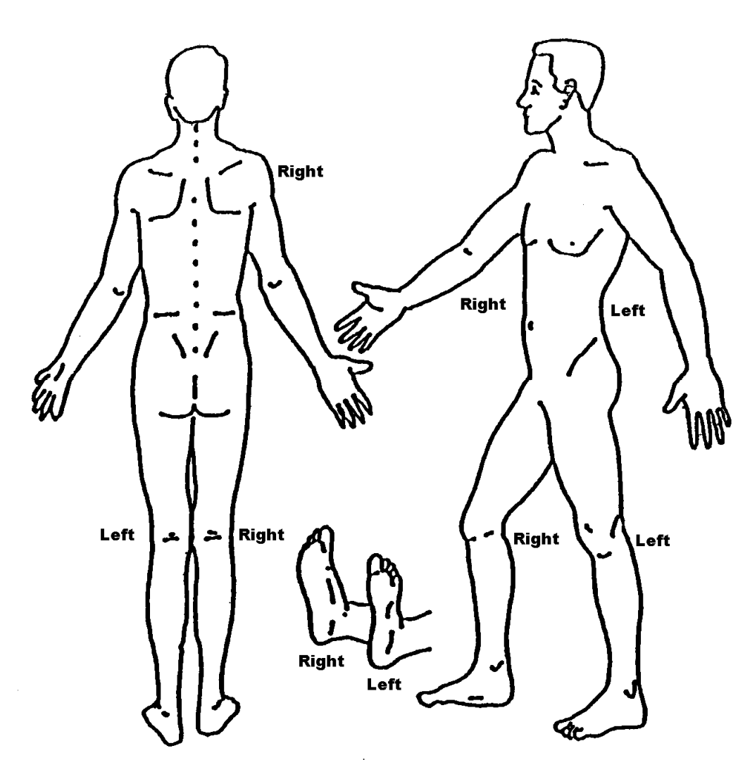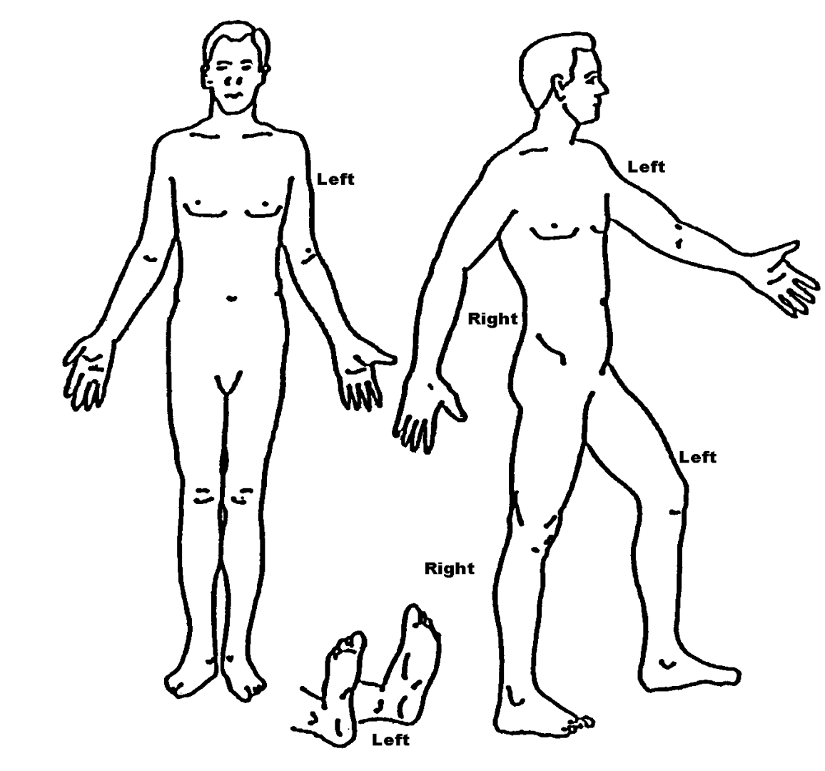==== Numbness 000 Pins& Needles _
Your Surgical History:
Have you experienced any major life changes/events:_
Please list concerns, in order of importance, that you would like to discuss today

Place sticker here Date

