FOR OFFICE USE ONLY ____ PA ____ AW ____ SM

ewbc.com select: Resources, select: Patient Satisfaction Survey

    

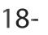  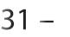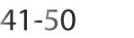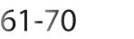 

  
   

              
 

 | Excellent | good | fair | poor | not applicable
Please circle
Was the EWBC staff friendly, knowledgeable & helpful?
Front desk/reception | 4 | 3 | 2 | 1 | NA
Technologist (performed mammogram) | 4 | 3 | 2 | 1 | NA
Medical Assistant ( gave results) | 4 | 3 | 2 | 1 | NA
Sonographer (performed ultrasound) | 4 | 3 | 2 | 1 | NA
Were you able to make an appointment quickly and easily? | 4 | 3 | 2 | 1 | NA
Were you greeted with a smile? | 4 | 3 | 2 | 1 | NA
Upon arrival, was the registration quick & efficient? | 4 | 3 | 2 | 1 | NA
How thoroughly was your procedure explained to you? | 4 | 3 | 2 | 1 | NA
Do you feel your exam was performed professionally? | 4 | 3 | 2 | 1 | NA
If you met with a physician, was she/he polite & informative? | 4 | 3 | 2 | 1 | NA
How would you rate the comfort and cleanliness of our facility? | 4 | 3 | 2 | 1 | NA
Overall, how would you rate the quality of care you received? | 4 | 3 | 2 | 1 | NA
ow would you rate your total visit time? | 4 | 3 | 2 | 1 | NA


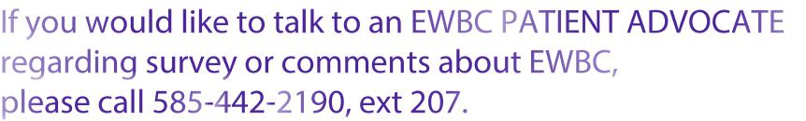

8/22/16

