SAMPLE Dental Consent and Medical History Form for an Adult

____________________________________________________________________________

(Name of Public Health Dental Hygienist and/or Program)

Please print in ink

Name: _________________ __________________________

Date of Birth: _ _/_ _ /_ _ _ _ Male Female Email Address: _______________________________

Address: __________________________________________________________________________________________
(Street) (City/town) (State) (Zip Code

Phone: ________________________________ Email: _____________________________________________

Social Security Number __ __ __ -__ __- __ __ __ __ Adult/Long Term Care Facility ____________________

Please tell us your race:
American Indian/Alaskan Native Asian Black/African American Hispanic/Latino White Other

Health Information:
1. Are you taking any medication now? YES NO

If yes, please list both prescribed and over the counter medications that you take in the space below:

2. Has a dentist or physician ever told you that you need to take antibiotics (penicillin) before having dental treatment? YES NO

3. Please check any illnesses or conditions you have EVER had:
Alcohol abuse | Drug Abuse | Rheumatic Fever
Allergies to Medicine(s) | Epilepsy | Shingles
Anemia or blood problems | Glaucoma | Sinus problems
Any Heart Ailments | Heart Murmur | Stroke
Arthritis | Hepatitis A, B, C | Thyroid Problems
Artificial Joint | High Blood Pressure | Tuberculosis
Asthma | Immune system, HIV, AIDS, ARC | Ulcer or colitis
Cancer or Chemotherapy | Kidney problems | Use of tobacco, cigarettes, chew
Diabetes | Liver problems | Sexually Transmitted Disease
 | Psychiatric care/emotional problems

4. Do you have any other health conditions? YES NO

If yes, please list.__________________________________________________________________________

5. Do you have any allergies? If yes, please check all that apply: YES NO

Penicillin Antibiotics Anesthetics Colophonium Aspirin Foods Latex Resins Other: __________

6. Do you have a dentist? YES NO
Name of dentist and office location: __________________________________________________________

When did you last see your dentist? ____________________________________________________________

7. What do you do to take care of your teeth and gums?
Daily tooth brushing Daily flossing Inter-dental stimulators Water jet device

8. Do you have any pain in your mouth today? YES NO

9. Do you have DENTAL INSURANCE? YES NO

If you have dental insurance, please check which one and complete below:

Blue Cross/Shield Delta Dental Mass Health/Medicaid Other ______________________

Delta Dental, CMSP, or Other Dental Insurance

Company_____________________________________
Address______________________________________
Subscriber____________________________________
Subscriber ID #________________________________
Subscriber’s Date of Birth _____ /______/_________
Subscriber’s Social Security Number_ _ _/_ _/_ _ _ _
Group/Policy #________________________________
Employer Name_______________________________

MassHealth
MassHealth RID Number
_______________________________

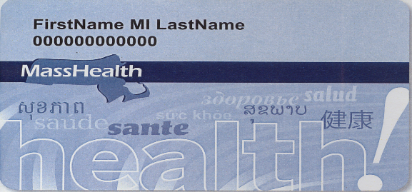

I understand that the dental provider, __________________________________, may use my health information for treatment, payment and health care operations. I have been given a copy of the Dental Provider’s Notice of Privacy Practices.

I have read and understand the services that may be provided to me by this dental program and I consent to participate. I understand that I may continue to obtain dental care through any other provider. I understand that these services are not a substitute for an examination by a dentist. I understand that I should obtain a dental examination by a dentist within 90 days, if I have not had one, and if needed, this program will provide me with a list of dentists in my area.

I authorize the dental provider to consult with my medical provider(s) as may be appropriate to my health and the provision of dental care. If applicable, I authorize the dental program to provide a written summary of the examination and services provided to the official designee of my long term care facility or residential facility or institution.

If I have dental insurance, I authorize my insurance carrier to be billed for any services provided. I understand that this treatment may affect my future rights and benefits under my dental insurance. If I do not have dental insurance, I will pay the Dental Provider for all dental services that are charged to me.

X____________________________________ Date: ___/___/___ Relationship to Patient: ____________________

Patient/Legal Representative Signature
_______________________________ ___________________________ ______________________________
Print Name Daytime Phone Number Cell Phone

