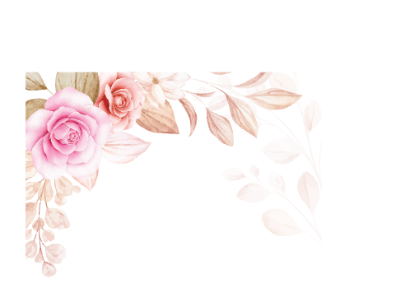

For You!

The beauty of these roses cannot match the beauty and depth of the love I feel for you. You are always in my heart!

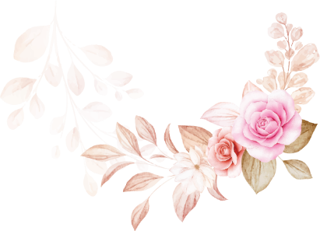

For You!

The beauty of these roses cannot match the beauty and depth of the love I feel for you. You are always in my heart!