

Stress Relief Guide

Index

Your Stress-Coping Plan........................................... Page 2

The Feelings Wheel.................................................. Page 3

Stress Strategies...................................................... Page 5

Build Your Resilience................................................ Page 6

Foods for Resilience................................................. Page 7

How to Use the Stress Relief Guide

The Stress Relief Guide is designed to help you find immediate stress relief, understand the real root of your stress, and build your inner strength (aka resilience), to improve your long-term stress response. Here’s how to use the guide:

I. Develop Your Stress Coping Plan

Focus on developing your personal stress plan over time. This plan is designed for you to develop during any emotional state.

II. When You Feel Stressed...

A. Use your Stress-Coping Plan (once developed)

or

B. Turn to the Immediate Stress Strategies section on page 5 and continue to develop your Stress Coping Plan as time allows.

III. Build Your Long-term Resilience

Incorporate resilience-building strategies into your everyday life using the

Resilience Builders guide on page 6.

Nourish your brain with resilience-building foods, (pages 7 - 8).

Stress Relief Guide | 1


My Stress-Coping Plan

Identify Your Feelings

How am I feeling right now in this moment? (Use the accompanying Feelings Wheel on page 4 for help.)

Stress Signals and Behavior

What do I tend to do when I am feeling stressed? (For example: pour an alcoholic drink, turn to food for comfort, get angry, shake, lose focus, etc.)

1.

2.

3.

My Coping Go-Tos

Activities I can do right now that will help to take my mind off my problems:

(Use the Stress Strategies on page 5 for a list of coping ideas.)

1.

2.

3.

4.

People who make me feel better

(Choose friends or loved ones who are great listeners and/or help you to feel better about situations, rather than worse.)

Name:

Name:

Name:

Places that make me feel better

Place:

Place:

Place:

Professionals (such as a counselor) or agencies I can contact during a crisis

Agency/Clinician Name: | Phone:
Agency/Clinician Name: | Phone:
Local Emergency Service: Community Crisis Number | Phone: 1-833-295-0616


Stress Relief Guide | 2


Exploring Your Feelings

Feelings are defined as our emotional state at any given time. They reveal how we are reacting to every

part – every moment – of our lives. Whether we welcome them (joy, excitement, awe) or not (sadness, anger, fear), these ever surfacing emotions are a bittersweet part of the human experience. While we cannot control the endless waves of emotions that continuously wash in, what we can control is how we cope with them.

Many people have been taught, often from an early age, to detach from their feelings and even feel ashamed of them. But understanding our feelings (aka emotional literacy) is how we connect to our true inner selves, face challenges in healthy ways, and build our inner strength or resilience.

Facing our deep-down feelings rather than “moving on” might not make sense at first glance, especially when these feelings are upsetting. But we can’t truly move past these feelings – and more importantly, the situation causing them – without giving ourselves permission to experience them head-on. The trouble is, identifying our exact emotions in any given situation can be challenging, if not downright uncomfortable. A list of emotions words or a Feelings Wheel like the one below can help you.

About the Feelings Wheel

During his career, American psychologist Robert Plutchik, PhD, distinguished eight basic emotions: joy, fear, surprise,

sadness, acceptance, disgust, anticipation, and anger. Plutchik then placed these core emotions at the center of his Wheel

of Emotions – a useful emotional vocabulary tool designed to help people name their emotions in order to better understand

and face them.

This same wheel concept has been adapted for you on page 4. The Feelings Wheel can help you identify your core emotion(s) and even determine their level of intensity. For example: annoyance versus disgusted or thrilled versus satisfied.
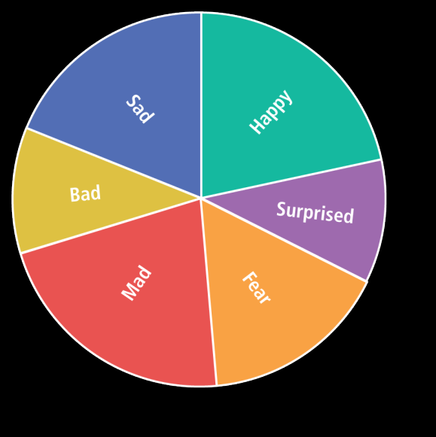

How to Use the Feelings Wheel

Begin at the center of the wheel to determine your primary emotion(s). Then follow the color or color range of your emotion(s) out as far from the center as you can to identify the deeper emotions that are likely at the root of what you’re experiencing. It may even be a combination of emotions, as is often the case.

You’ll also see that each emotion intentionally overlaps with two others. For example, the core emotion “mad” might can be commonly connected to sadness. That’s because a situation that stirs our anger might really be masking sadness or resentment over something more significant.

Stress Relief Guide | 3

The Feelings Wheel

Sorry | Rejected | Exploited
Embarrassed
Defenseless
Hopeless

 |  | Empty
 |  | Hurting
 |  | Uncaring |  |  | Abandoned
 | Detached |  |  | Guilty | Abandoned
Neglected |  |  | Despair | Guilty | Abandoned
 |  |  | Depressed
Isolated |  |  | Depressed
Isolated |  | Bored
Hearbroken
Hearbroken |  | Lonely
Abandoned |  | Lonely
Rejected |  | Grief
Embarrassed |  | Grief | Sad
Embarrassed |  | Hurt
Resentful |  | Hurt

Thrilled
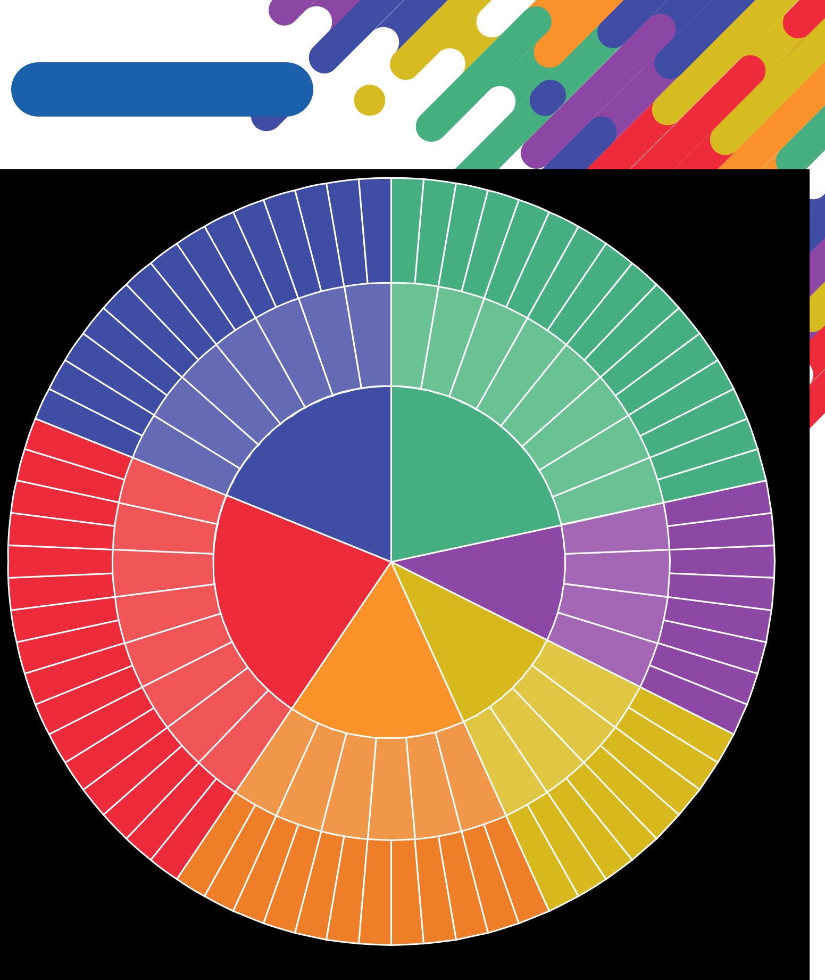

Joyful

Pleased | Hopeful | Energized

Optimistic | Acknowledged

Happy

Appreciated

Confident

Respected | Proud
 | Courageous
 | Peaceful
 | Thankful
 | Satisfied
Content |  | Confident
 |  | Loving
 | Proud | Loving
 | Proud | Open
 | Trusting | Successful
 | Trusting | Inspired
 | Productive | Puzzled

Disgusted Hateful

Confused Shattered

Irritated | Frustrated
Disappointed | Mad
Jealous | Threatened

Surprised | Shocked | Upset
Surprised |  | Disturbed
 | Amazed | Awe

Unsafe | Aggressive

Fear

Bad | Excited | Impressed

Provoked |  |  | Disapproving
Destructive |  |  | Disapproving
Destructive |  |  | Angry
Doubtful |  |  | Angry
Doubtful |  |  | Unfriendly
Sarcastic |  |  | Unfriendly
 | Furious |  | Unfriendly
 |  | Annoyed
 |  |  | Detached
 |  |  | Distrustful

Intimidated

Rejected

Helpless

Insecure

Anxious/Restless

Upset

Stressed

Scared

Exhausted | Antsy
Lousy | Energetic
Lousy | Tired
 | Unfocused
 | Awful
 | Disgusted
Agitated
Uneasy

Afraid | Discouraged

Inadequate | Humiliated

Unimportant

Stupid

Worthless

 |  |  |  | Worried
 |  |  |  | Overwhelmed
 |  |  |  | (see
Inadequate | Overwhelmed |  | Terrified
Inadequate | Overwhelmed | Worried | Panicked | fear)

Stress Relief Guide | 4


Stress Strategies

Defeating stress and building resilience is very individual – what works for one person may not work for someone else. The most helpful strategies are also situational: a 5 - 10 minute power walk or even some deep breaths near an open window may be more accessible than your yoga mat, for example. We suggest sampling the different stress strategies listed below to determine what activities work best for you…and when.

While you can turn to the immediate stress helpers at any time, we encourage you to name and sit with your feelings (using the Feelings Wheel on page 4) so you can truly work through your emotions, pinpoint the exact cause of your stress, and find more long-term solutions.

Immediate Stress Relievers When You’re Working or On the Go

(*try these for 5-10 minutes or longer if your schedule allows)

- Give yourself permission to explore your feelings

- Take slow deep breaths, pausing briefly in between your inhales and exhales

- Meditate or pray

- Drink some cold water or have a cup of tea

- Get some fresh air or sit near an open window

- Turn on some music or a podcast you enjoy (keep headphones handy at work or in situations where you need them)

- Take a quick walk

- Seek a quieter space away from loud noises and distractions

- Think of three things you’re grateful for

- Resist the urge to reach for sugary snacks that will affect your blood sugar and mood

- Focus on something in nature if you can get near a window or outside. For example: Watch the birds or focus on a tree or a patch of flowers

- Try Emotional Freedom Technique (EFT), aka tapping

- Go into mindfulness mode (focusing on being engaged on what you’re doing at the moment, rather than letting your mind wonder)

- Remember that you are not alone

When You Have More Time

- Reflect on what you are feeling and allow yourself to “sit” with your emotions

- Take a longer walk

- Write in a journal about how you’re feeling

- Read a book, blog, or magazine

- Watch a TV show or movie that makes you feel good or laugh

- Do some exercise that you enjoy, like dancing, running, tennis, or yoga

- Call a supportive friend

- Schedule a call with your counselor

- Color

- Light some candles or diffuse some soothing essential oils

- Play with your kids or grandkids

- Start a craft project

- Lie down with a cool cloth on your face

- Clean something

- Mow the lawn or garden

- Take a bubble bath

- Adopt/spend more time with a pet

Stress Relief Guide | 5


Build Your Resilience

Resilience is the ability to adapt well to challenges, trauma, tragedy, threats, or times of stress – such as family and relationship problems, serious health problems, or workplace and financial and stressors. (Source: American Psychological Association).

When life throws challenges of any size your way, resilience can help you cope better and bounce back faster.

Think of resilience as a special inner force that can help protect your mind and body from the impact of stress.

Remember to incorporate these important ongoing resilience builders as much as possible throughout the week (even when you’re not feeling stressed).

- Get a good night’s sleep – aim for 7 - 8 hours

- Incorporate resilience-building foods (see page 7)

- Exercise

- Do activities that provide an immediate sense of accomplishment or control

- Focus your energy on relationships that make you feel good or better, rather than those that drain you or make you feel stressed, sad, anxious, or angry

- Seek mental health support, such as a counselor, to help work through ongoing situations that cause you stress
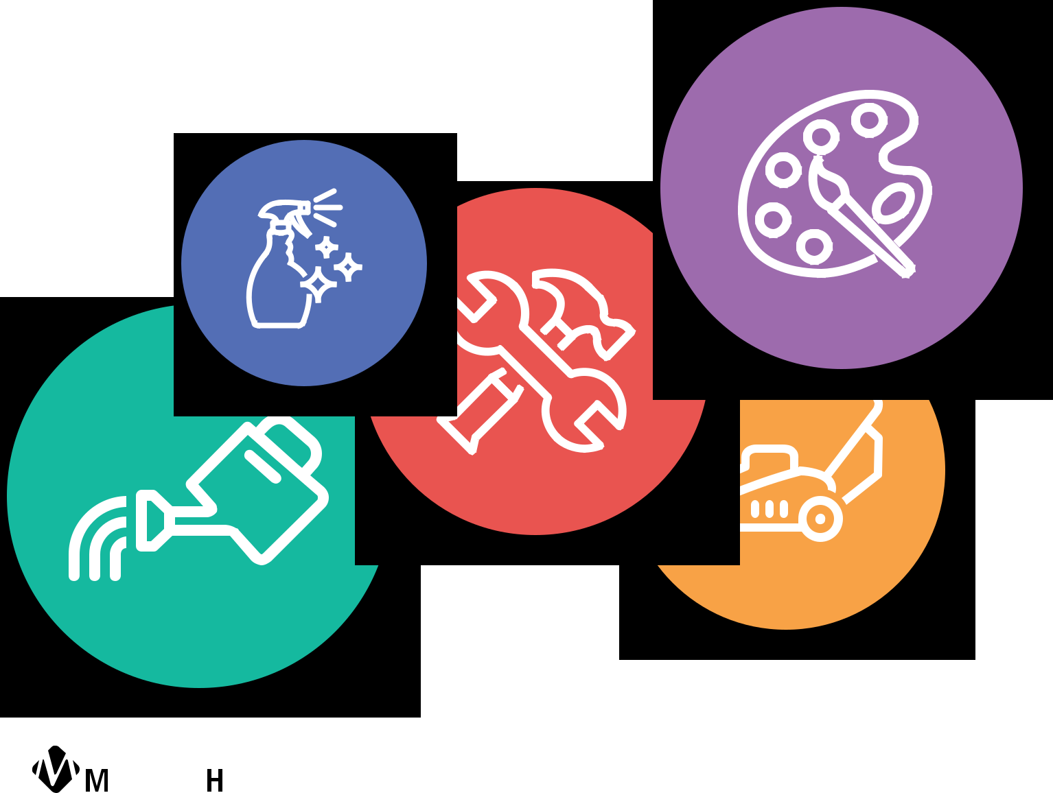

Stress Relief Guide | 6


Foods that Build Resilience

Just as they impact our bodies, the foods we eat also affect our mental health. Nourishing our bodies with a wide variety of foods that contain certain nutrients like the ones listed below can help feed our brains, regulate the nervous system, and fight anxiety, depression, and other mental illnesses. 

Think about incorporating as many of these nutrients (as you individually tolerate them) in each meal as possible. Foods that cover three or more categories are in bold.

Antioxidants

Protect against oxidative stress, which may be linked to mental illness and other chronic diseases.

- Cacao

- Fruits and vegetables

- Green tea

- Legumes (beans and lentils)

- Seeds (chia, ground flaxseed, hemp seed)

- Whole grains (oats, quinoa, wild rice, farrow, whole wheat, buckwheat, popcorn, etc.)

B vitamins

B vitamins play a large role in helping our nervous system function. Low levels of certain B vitamins including B-12, B-6, and folate may be linked to depression (Source: Mayo Clinic).

- Dairy

- Eggs

- Fish

- Leafy Greens

- Legumes (beans and lentils)

- Meat

- Nutritional Yeast

- Nuts (such as almonds, pistachios, walnuts. Nut butters count!)

- Seeds (chia, flaxseed, hemp seed)

- Whole Grains

Vitamin D

Vitamin D, aka the “Sunshine vitamin” may play a role in brain function. Several studies have shown a link between low levels of vitamin D and anxiety and/or depression.

- Cereals (fortified only)

- Dairy and non-dairy products like milk and yogurt (fortified only)

- Eggs

- Fish

- Fish liver oil, like cod

- Wild mushrooms

Stress Relief Guide | 7


Magnesium

Magnesium helps regulate your neurotransmitters, which serve as chemical messengers to communicate between your brain and nervous system. Magnesium has been shown to reduce symptoms of depression.

- Nuts and Seeds (pumpkin, chia, almonds, cashews, peanuts)

- Legumes (edamame, kidney beans, chickpeas)

- Fruits and vegetables (banana, avocado, broccoli, apple, carrots)

- Cacao and 70-85% dark chocolate

Omega 3’s

Omega 3 fatty acids fight inflammation, which may be tied to depression and other mental illnesses. These brain boosters are important for normal brain function.

- Fatty fish like salmon, sardines, mackerel, herring, and oysters

- Seeds (chia, flaxseed, hemp seed)

- Walnuts

Prebiotics/Probiotics

Recent studies have revealed an astonishing link between our gut health and our brain health. A poor gut ecosystem (having more bad versus good bacteria) has been linked to many diseases including depression. Prebiotics feed the healthy bacteria that we need in our guts while probiotics help to deliver more of the good bacteria we may be lacking.

Prebiotic Foods: |  |  | Probiotic Foods:
• | Artichokes |  | • | Kefir
• | Bananas |  | • | Kimchi*
• | Garlic |  | • | Sauerkraut*
• | Leeks |  | • | Kombucha
• | Onions |  | • | Yogurt (both dairy and non-dairy variations containing live cultures)
• | Soybeans | * |  | When purchased in the refrigerator section only.

Zinc

Zinc plays a critical role in assisting communication among our brain cells.

- Cereals (fortified only)

- Dairy

- Legumes (beans and lentils)

- Nuts

- Chicken and other poultry

- Seafood

- Whole grains

Stress Relief Guide | 8

