Personal Information: |  |  |  |  |  | CLIENT INTAKE FORM-THERAPUTIC MASSAGE
Name |  |  |  |  |  |  |  | Phone (Day) |  |  |  | Phone (Eve)
Address
City/State/Zip
email |  |  |  |  |  |  |  | Date of Birth |  |  |  | Occupation
Emergency Contact |  |  |  |  |  |  |  |  |  |  |  | Phone

The following information will be used to help plan safe and effective massage sessions. Please answer the questions to the best of your knowledge.

Date of Initial Visit
1. | Have you had a professional massage before? |  |  |  |  |  |  |  | Yes | No
 | If yes, how often do you receive massage therapy?
2. | Do you have any difficulty lying on your front, back, or side? |  |  |  |  |  |  |  |  |  |  | Yes | No
3. | If yes, please explain
 | Do you have any allergies to oils, lotions, or ointments? |  |  |  |  |  |  |  |  | Yes |  | No
 | If yes, please explain
4. | Do you have sensitive skin? |  |  |  |  |  | Yes | No
5. | Are you wearing contact lenses ( ) dentures ( ) a hearing aid ( |  |  |  |  |  |  |  |  |  |  | ) ?
6. | Do you sit for long hours at a workstation, computer, or driving? |  |  |  |  |  |  |  |  |  |  |  | Yes |  | No
 | If yes, please describe
7. | Do you perform any repetitive |  |  |  |  | movement in your work, sports, or hobby? |  |  |  |  |  |  |  |  | Yes | No
 | If yes, please describe
8. | Do you experience stress in your work, family, or other aspect of your life? |  |  |  |  |  |  |  |  |  |  |  |  |  | Yes | No
 | If yes, how do you think it has affected your health?
 | muscle tension ( ) anxiety ( ) |  |  |  |  |  |  | insomnia ( | ) irritability ( |  |  | ) other
9. | Is there a particular area of the body where you are experiencing tension, |  |  |  |  |  |  |  |  |  |  |  |  | stiffness, pain
 | or other discomfort? Yes |  |  |  |  |  | No
 | If yes, please identify
10. Do you have any particular goals in mind for this massage session? |  |  |  |  |  |  |  |  |  |  |  |  | Yes |  | No
 | If yes, please explain
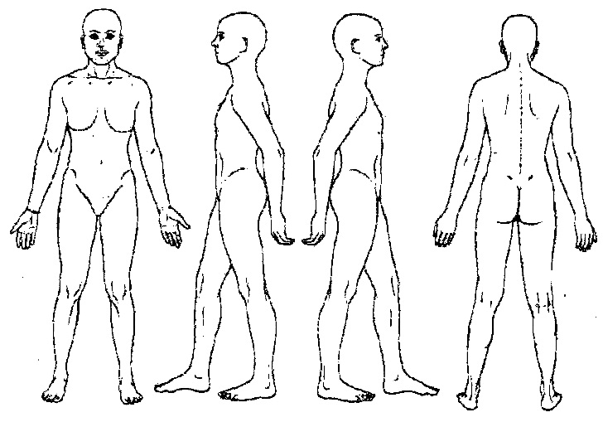
Circle any specific areas you would like the massage therapist to concentrate on during the session:

Continued on page 2

Medical History

In order to plan a massage session that is safe and effective,

I need some general information about your medical history.

11. Are you currently under medical supervision? Yes |  |  |  |  |  |  | No
 | If yes, please explain
12. Do you see a chiropractor? Yes |  |  |  |  | No | If yes, how often?
13. | Are you currently taking any medication? |  |  |  |  | Yes | No
 | If yes, please list
14. Please check any condition listed below that applies to you:
 | ( | ) contagious skin condition |  |  | ( | ) phlebitis
 | ( | ) open sores or wounds |  |  | ( | ) deep vein thrombosis/blood clots
 | ( | ) easy bruising |  |  | ( | ) joint disorder/rheumatoid arthritis/osteoarthritis/tendonitis
 | ( | ) recent accident or injury |  |  | ( | ) osteoporosis
 | ( | ) recent fracture |  |  | ( | ) epilepsy
 | ( | ) recent surgery |  |  | ( | ) headaches/migraines
 | ( | ) artificial joint |  |  | ( | ) cancer
 | ( | ) sprains/strains |  |  | ( | ) diabetes
 | ( | ) current fever |  |  | ( | ) decreased sensation
 | ( | ) swollen glands |  |  | ( | ) back/neck problems
 | ( | ) allergies/sensitivity |  |  | ( | ) Fibromyalgia
 | ( | ) heart condition |  |  | ( | ) TMJ
 | ( | ) high or low blood pressure |  |  | ( | ) carpal tunnel syndrome
 | ( | ) circulatory disorder |  |  | ( | ) tennis elbow
 | ( | ) varicose veins |  |  | ( | ) pregnancy If yes, how many months?
 | ( | ) atherosclerosis
Please explain any condition that you have marked above

- Is there anything else about your health history that you think would be useful for your massage practitioner to know to plan a safe and effective massage session for you?

Draping will be used during the session – only the area being worked on will be uncovered.

Clients under the age of 17 must be accompanied by a parent or legal guardian during the entire session. Informed written consent must be provided by parent or legal guardian for any client under the age of 17.

I, (print name) understand that the massage I receive is provided for the basic purpose of relaxation and relief of muscular tension. If I experience any pain or discomfort during this session, I will immediately inform the therapist so that the pressure and/or strokes may be adjusted to my level of comfort. I further understand that massage should not be construed as a substitute for medical examination, diagnosis, or treatment and that I should see a physician, chiropractor or other qualified medical specialist for any mental or physical ailment that I am aware of. I understand that massage therapists are not qualified to perform spinal or skeletal adjustments, diagnose, prescribe, or treat any physical or mental illness, and that nothing said in the course of the session given should be construed as such. Because massage should not be performed under certain medical conditions, I affirm that I have stated all my known medical conditions, and answered all questions honestly. I agree to keep the therapist updated as to any changes in my medical profile and understand that there shall be no liability on the therapist’s part should I fail to do so.

Signature of client |  |  |  | Date
Signature of Massage Therapist |  |  |  | Date

