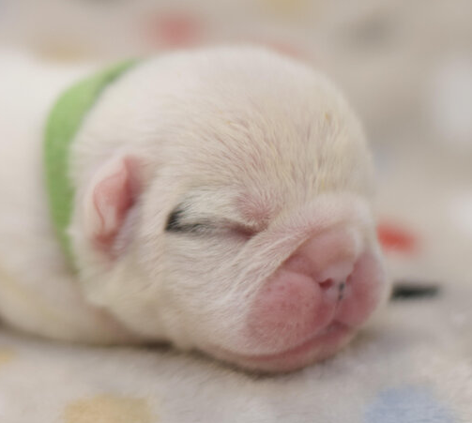



**Owner**

**Vet on duty**

**Mother**

**Father**

**Height**

**Weight**

**At**

**In the year**

**On this**

**Day of**

**This is to certify that**

