

BIRTH CERTIFICATE

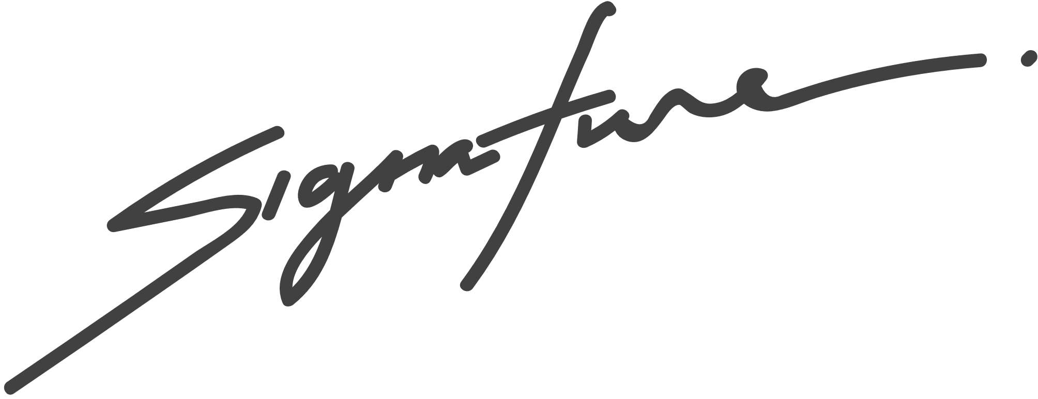

PUG NAME

Juliana Silva

Pet shop manager

This certifies that

is a male pug born on August 8th, 2021

to parents, David and Anna.

