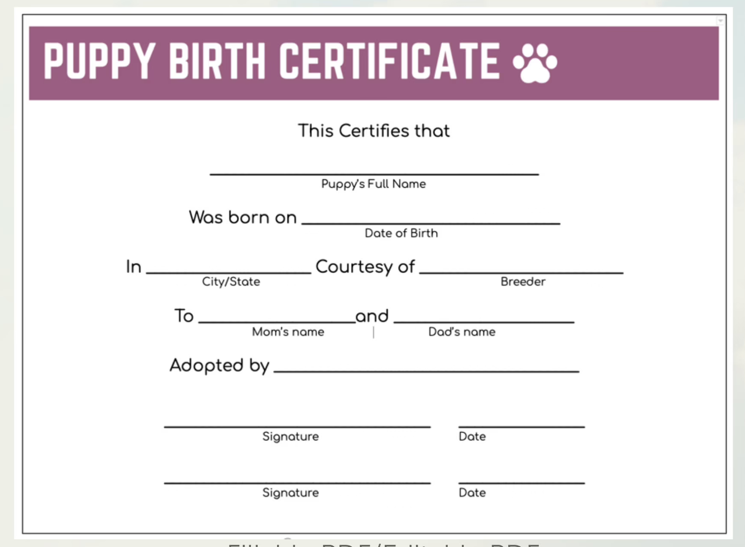

12.15. 2010

12.15. 2010

XYZ

XYZ

XYZ

Milo

Ollie

ABC

Austin, TX

December 01, 2010

Snow