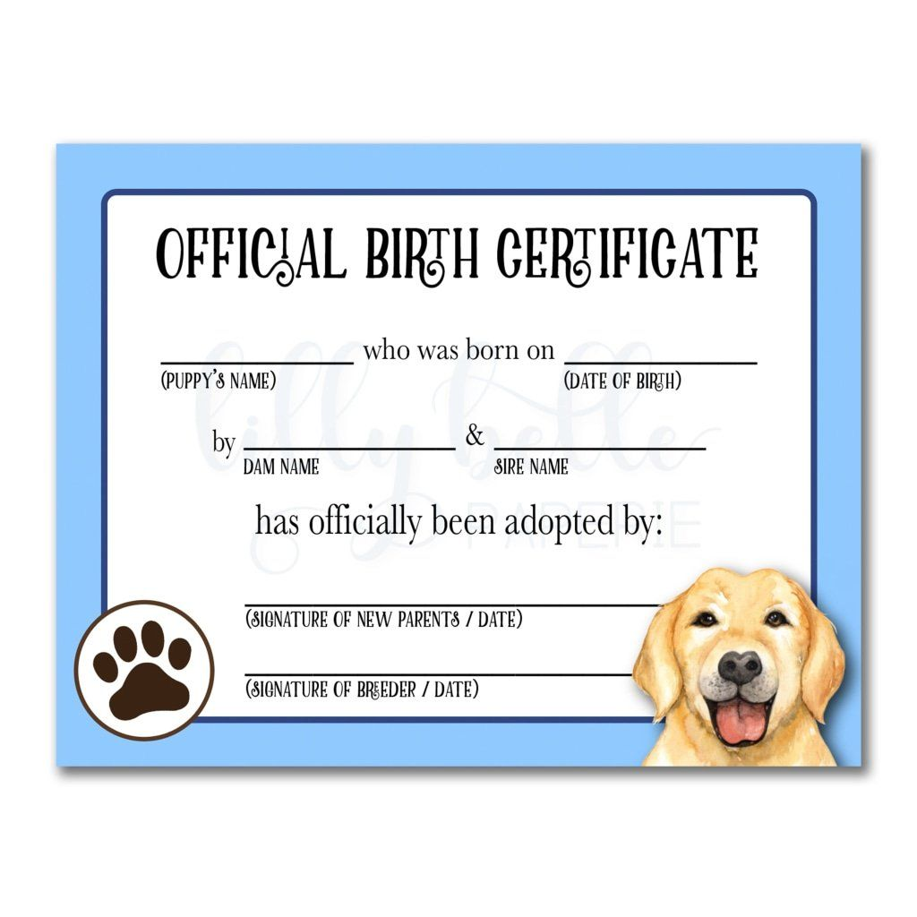

Smith

Smith Family 05.30.05

Smith Family 05.30.05

Rose Smith

Rose Smith

Rose Smith

Rose

Jack

05.05.05

Walter

Walter

Walter

Walter