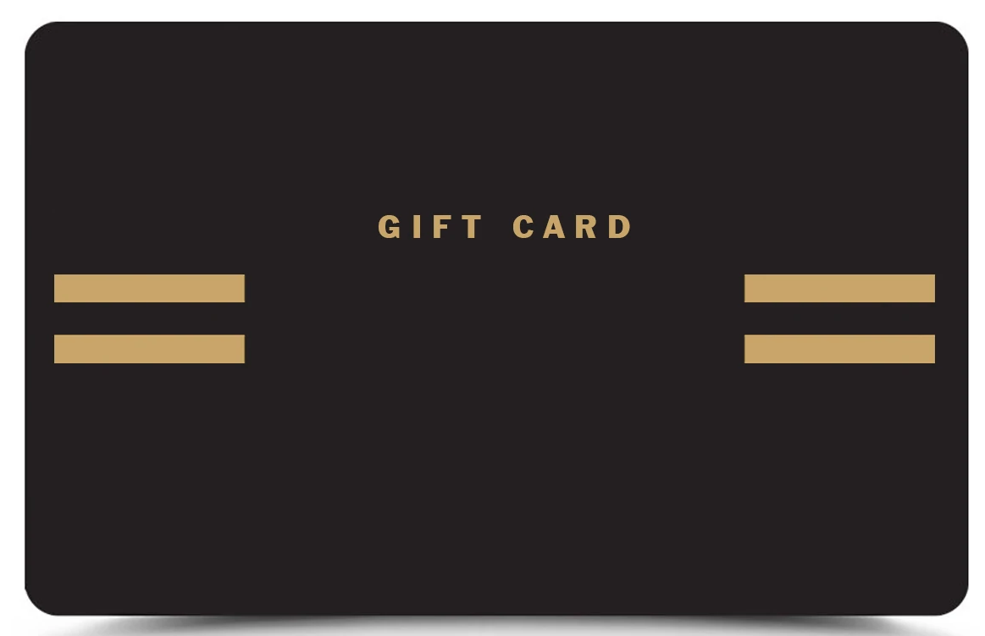

XYZ Tattoo Inc.

Valid Until 2020