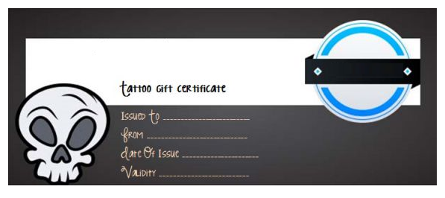

01/01/2021

01/01/2020

ALDOUS

JOHN SMITH

LOGO

Tattoo Shop