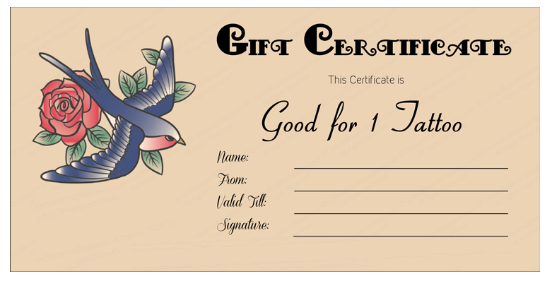

ABC

00/00/0000

ABC

ABC

Sample Address, Sample Phone Number, Website Name

**TATTO SHOP**

**NAME**