Massage Intake Form - CONFIDENTIAL INFORMATION

WELCOME! I would like to make your appointment as pleasant and comfortable as possible. If at any time you have questions regarding your session, please let me know.

Name |  |  |  |  |  |  |  | Date of birth
Address
State |  |  |  | City |  | Home Phone
Work Phone |  |  |  |  |  | Occupation
Have you ever received massage therapy? |  |  |  |  |  |  | Yes |  |  |  |  | No

Type of massage experienced (swedish, shiatsu, deep tissue, etc.)

Are you currently taking any medications? Yes No

If yes, please list name and reason for medications

Are you currently seeing a healthcare professional? Yes No If yes, please list names and reason/treatment

Please review this list and check those conditions that have affected your health either recently or in the past. Place a check mark next to the condition.

arthritis diabetes blood clots

broken/dislocated bones bruise easily

cancer chronic pain

constipation/diarrhea auto-immune condition* hepatitis (A, B, C, other) skin conditions

stroke surgery TMJ disorder

(*AIDS, fibromyalgia, chronic fatigue, lupus, etc.)

depression, panic disorder, other psych condition

diverticulitis headaches heart conditions back problems

high blood pressure insomnia

muscle strain/sprain pregnancy

scoliosis seizures whiplash
chemical dependency (alcohol, drugs)

If any of the above needs to be detailed or if there is anything else to share, please do so:

Do you have any of the following today:

skin rash |  | cold/flu |  |  | open cuts |  | severe pain
anything contagious |  |  |  | injuries/bruises

Do you have any allergies to:

medications foods (nuts, etc.)

environmental allergens (dust, pollen, fragrances) reactions to skin care products

If any of the above are checked, please give details:

Are you wearing: contact lenses hearing aid hairpiece

Please indicate with an (X), if any, the areas in which you are feeling discomfort:
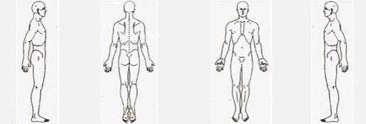

What are your goals/expectations for this therapy session?

The following sometimes occurs during massage. They are normal responses to relaxation. Trust your body to express what it needs to:

need to move or change position  sighing, yawning, change in breathing stomach gurgling  emotional feelings and/or expression
movement of intestinal gas  energy shifts  falling asleep  memories

Please read the following information and sign below:

- I understand that although massage therapy can be very therapeutic, relaxing and reduce muscular tension, it is not a substitute for medical examination, diagnosis and treatment.

- This is a therapeutic massage and any sexual remarks or advances will terminate the session and I will be liable for payment of the scheduled treatment.

- Being that massage should not be done under certain medical conditions, I affirm that I have answered all questions pertaining to medical conditions truthfully.

Signature: Date

