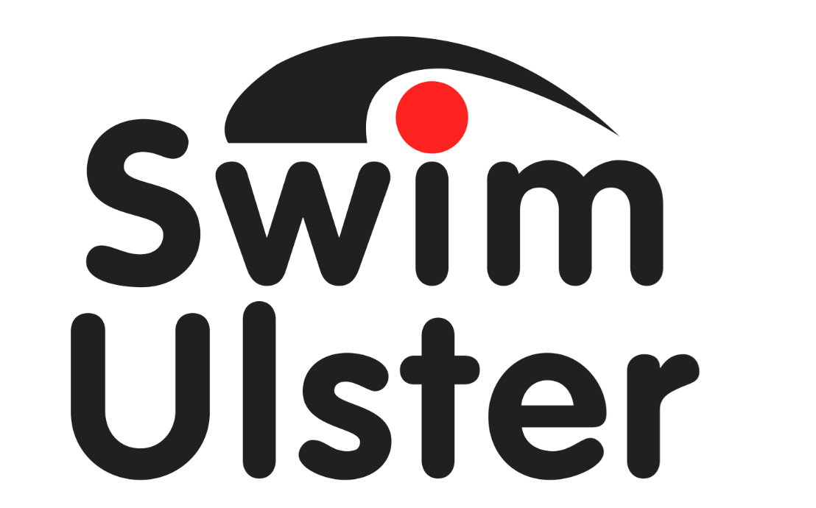

Swim Ulster Open Disability Swimming Championships 2018
in association with Disability Sport NI

NEWRY SWIMMING POOL
SATURDAY 3rd March 2018
PHOTOGRAPHY & VIDEO CONSENT FORM
Swim Ulster and Disability Sport NI will be taking photos and recording some of the performances throughout the day for promotional purposes. If you do not consent to your image being used please insert your name in the box below:

Name:
Club:

Please note that if you wish to use video or photography at any time during the Championships you are required to provide the following details:

Name:
Address:
Group/Individual
Associated with:

I confirm that the above details are correct
Signature:
Date:

Please return this form with your entry form and ask for your pass at registration on the day. This should be visibly worn throughout the duration of the competition.

Swim Ulster / Disability Sports NI and Newry Leisure Centre reserve the right to refuse the use of photography or video equipment at any stage throughout the Championships.

