
thanksgiving border

Sun | Mon |  | Tue

3 Time | 4 | 5
Change
10 | 11 Veterans |  | 12
 | Day
17 | 18 |  | 19
24 | 25 |  | 26
Elf

Wed


6

13

20

27

Thu | Fri
 | 1 All
 | Saints Day
7 | 8

- 15

Luncheon Bubba’s

21 | 22

28 Thanks 29

Giving Day

Sat

2

9

16

23

30

Happy Thanksgiving from your Senior Director and the entire staff at Long Lake Township and Long Lake Fire Rescue.

Thanksgiving Day brings to mind the blessings in our lives that usually go unnoticed: a home that surrounds us with comfort and protection; delicious food, for pleasure in both eating and sharing; clothes to snuggle up in, books and good entertainment to expand our minds; and freedom to worship our God. Most of all we are thankful for our family and friends, those treasured people who make our lives extra special. You are part of that cherished group. On Thanksgiving, (and every day) we appreciate you.

A special Thank You to the Grand Traverse County Senior Network for their help in funding the Long Lakers activities.

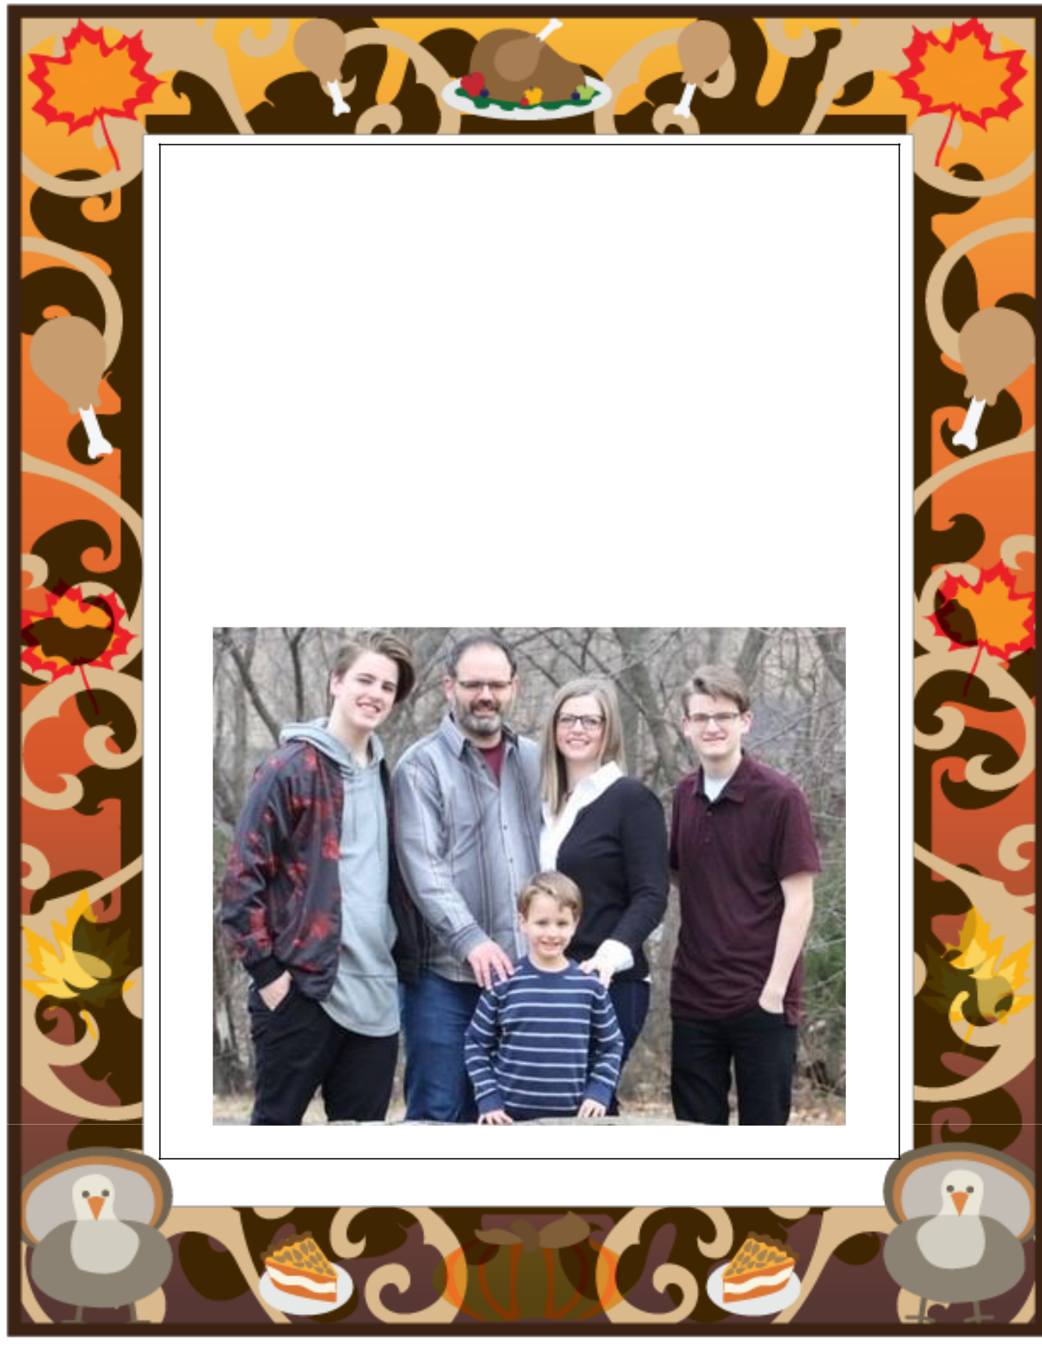
Jared Ingle serves as the Pastor of Long Lake Friends Church in Traverse City, Michigan. He and his wife Crystal come from a rich heritage of Christian leadership, three generations deep, on both sides of the family. While Jared has been in formal ministry since 1993, and is an Ordained Minister with the Pentecostal Church of God, together Jared and Crystal have served in active ministry since they were married in 1995. Jared and Crystal both obtained undergraduate degrees from Bible College. Jared also holds two masters from seminary.

Pastor Jared is part of the Online Faculty team for Messenger College. In addition, he is a Writer and Representative for an interdenominational discipleship commission. You can find some of his other writings at Patheos.com, where he is an Evangelical Columnist. Jared offers individual, couple, and family counseling as a Limited License Marriage and Family Therapist with supervision.

Christians are called to go into the world, rather than always trying to entice the world to come to us. So one crucial aspect of ministry is to recognize the God-given gifts and abilities in Christians, and then assist them as they become more active, either inside or outside of the four walls. Jared, Crystal, and their three sons look forward to witnessing what God will do at Long Lake Friends Church, a congregation where a high percentage of parishioners are already active.

