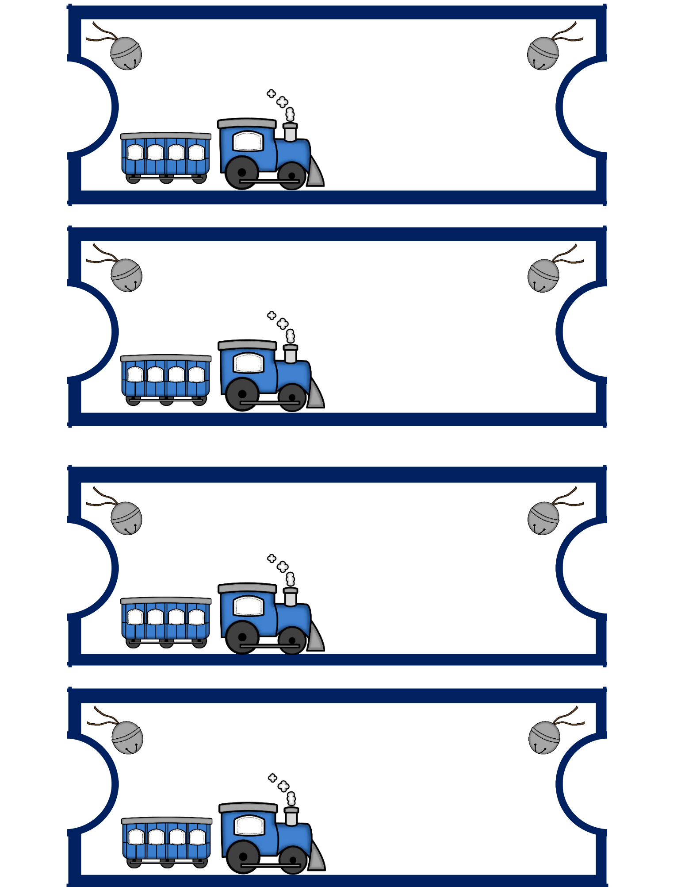
CaRTOON MOVIE
Movie Ticket – Admit One

Ticket #:

Screen 1, Sear # 1

CaRTOON MOVIE
Movie Ticket – Admit One

Ticket #:

Screen 1, Sear # 1

CaRTOON MOVIE
Movie Ticket – Admit One

Ticket #:

Screen 1, Sear # 1

CaRTOON MOVIE
Movie Ticket – Admit One

Ticket #:

Screen 1, Sear # 1

