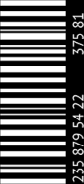pic.png

EVENING SESSION

MOVIE NAME

$6

B2

APRIL

21

21 APRIL - SATURDAY - 9:00 PM

TICKET NO: 43210