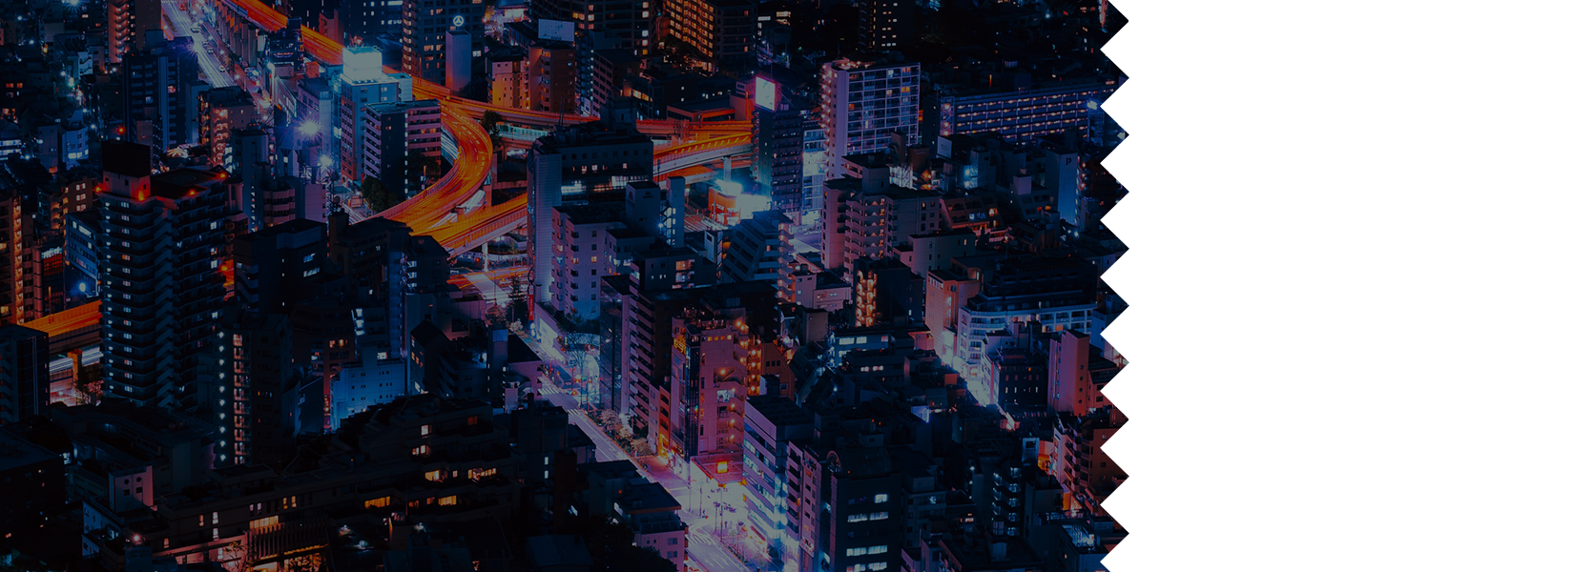

Movie Ticket no. 0124356

FREE SEATING

**ADMIT ONE**

**MIDNIGHT PRODUCTION PRESENTS**

12.12.19

**Directed by John Doe**

The end